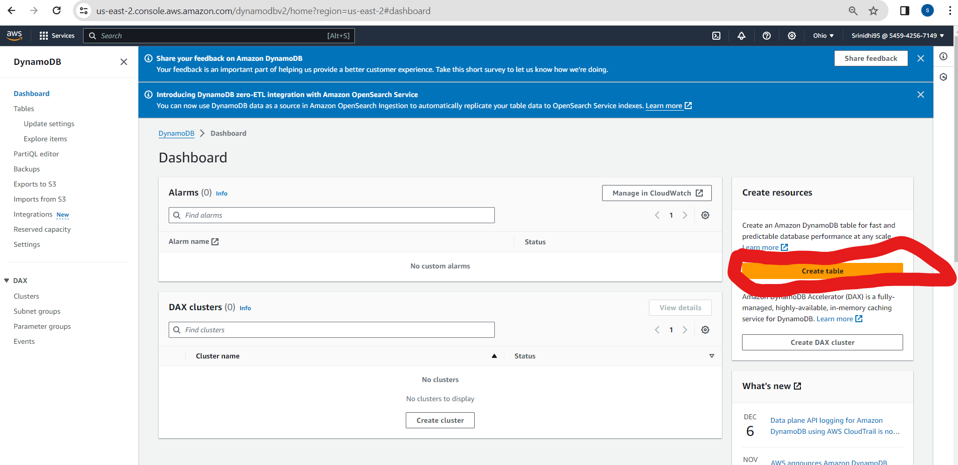

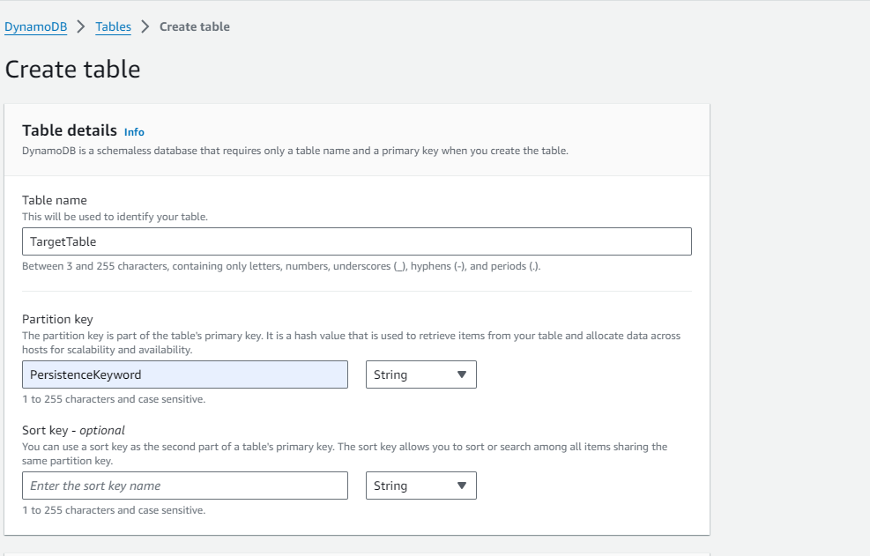

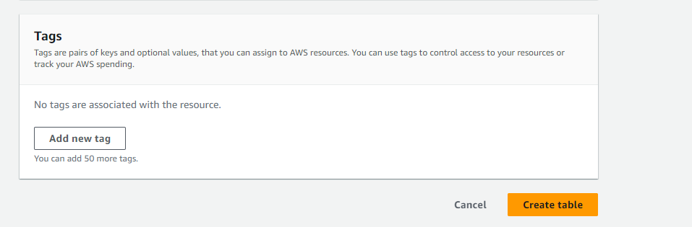

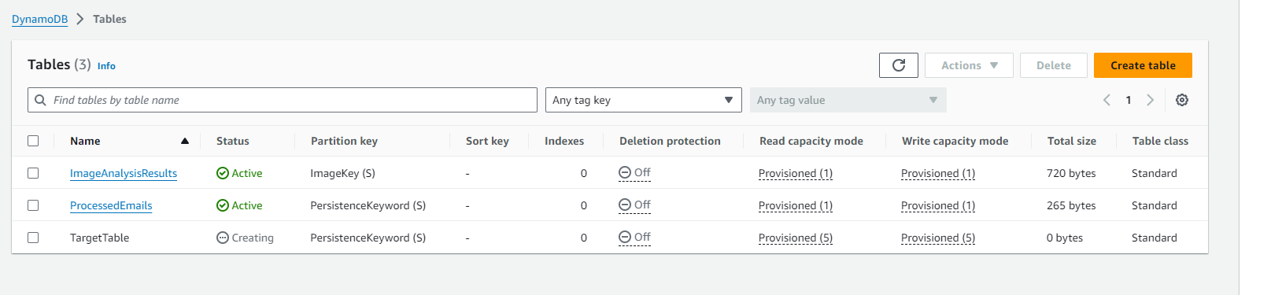

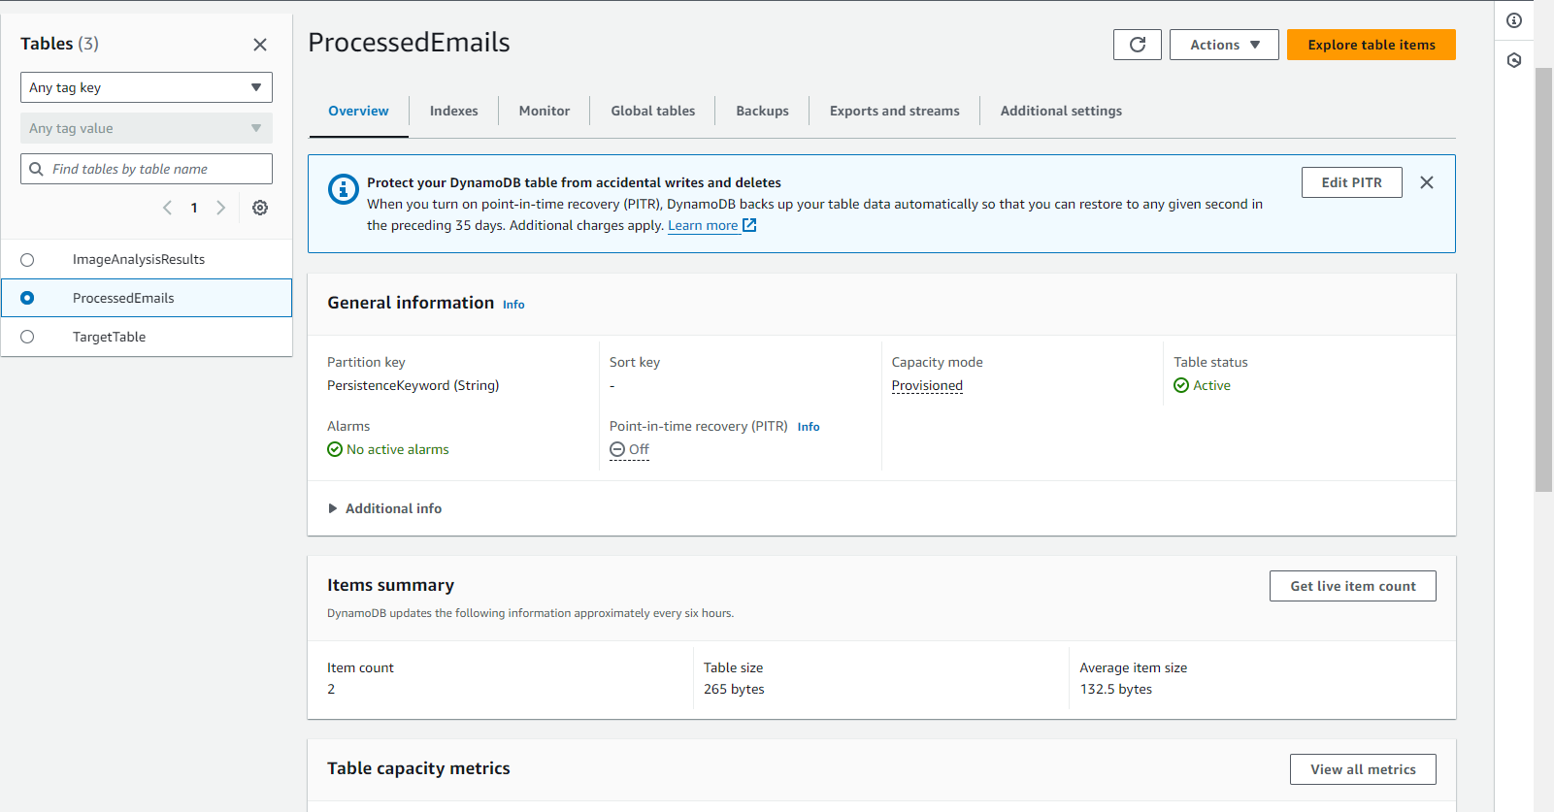

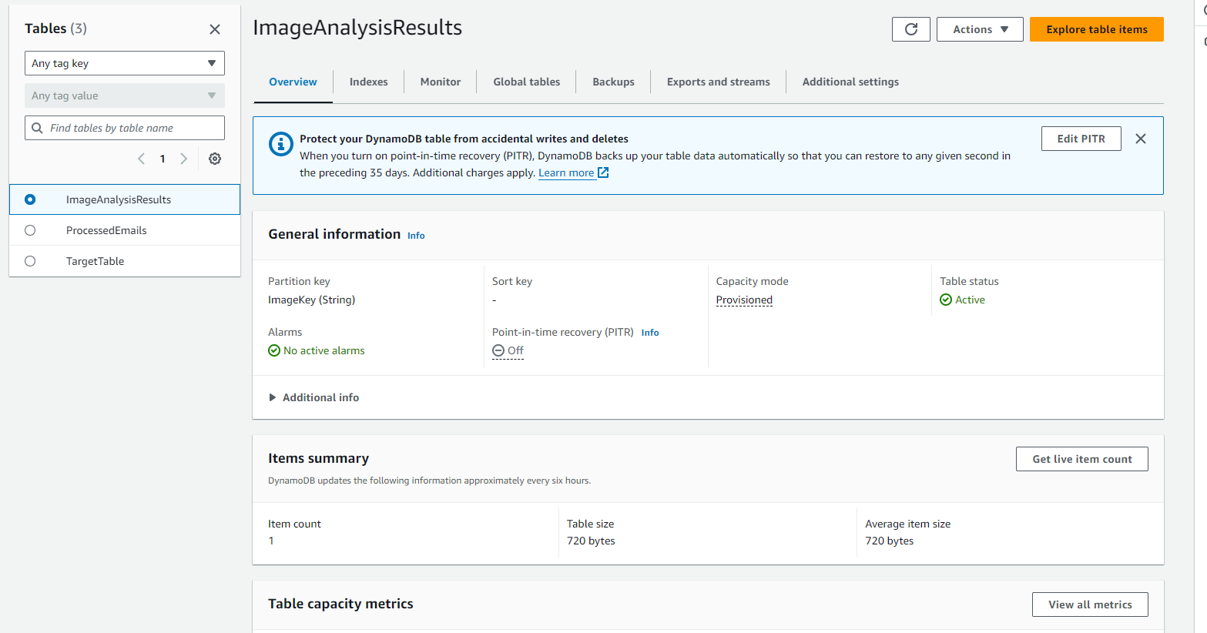

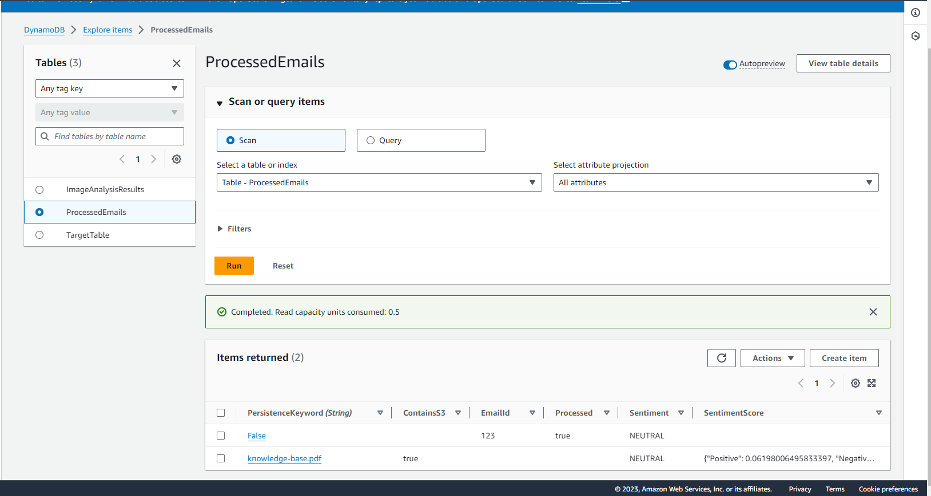

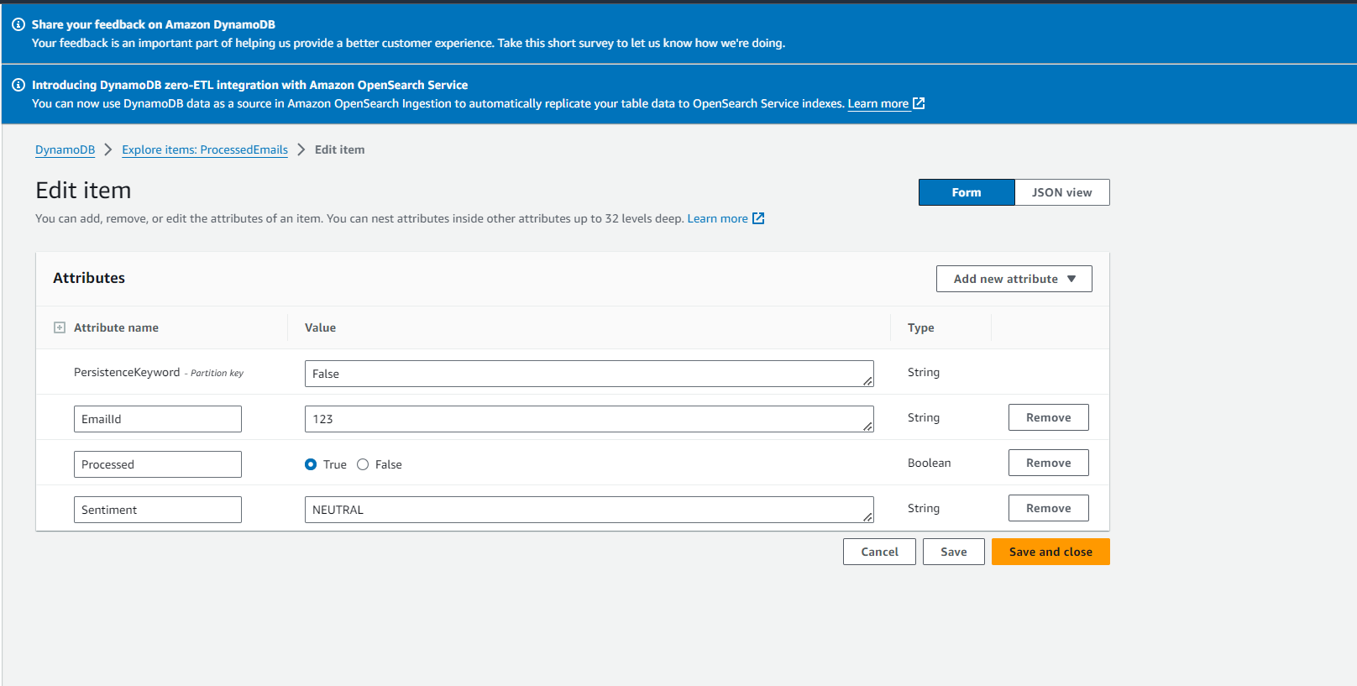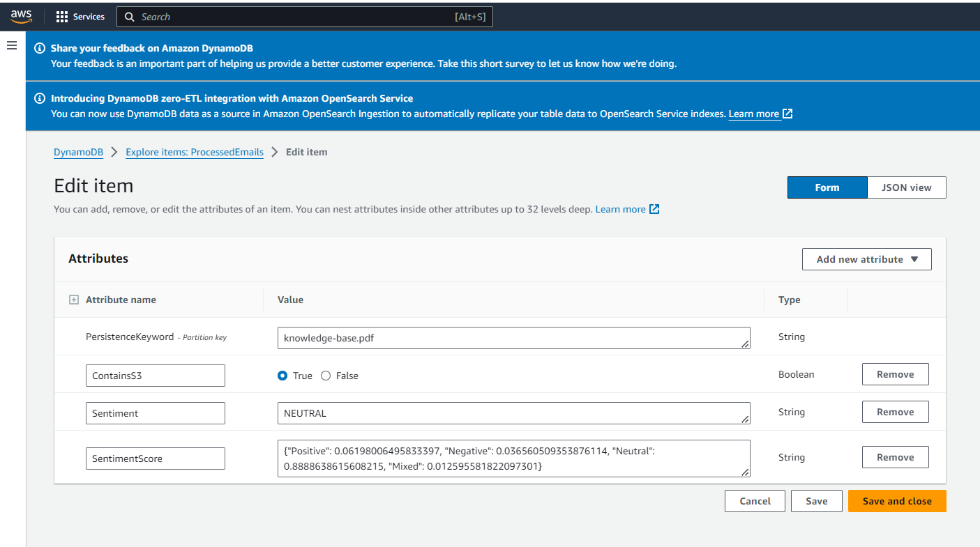

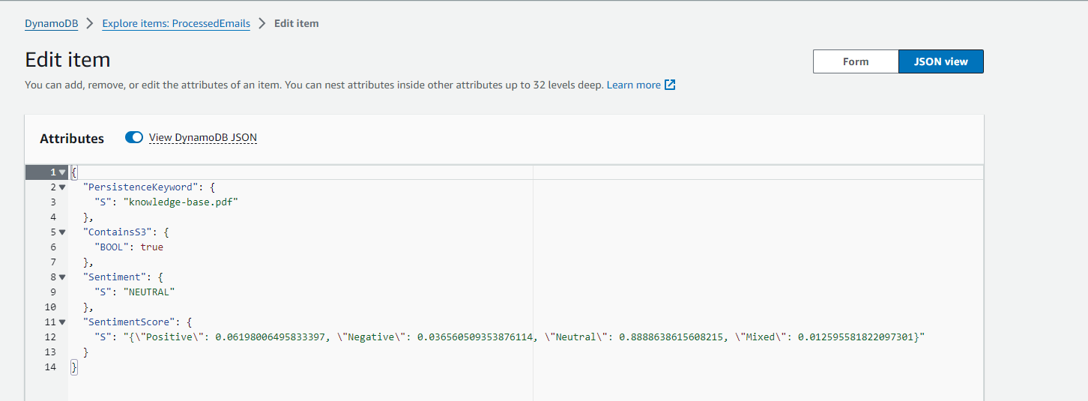

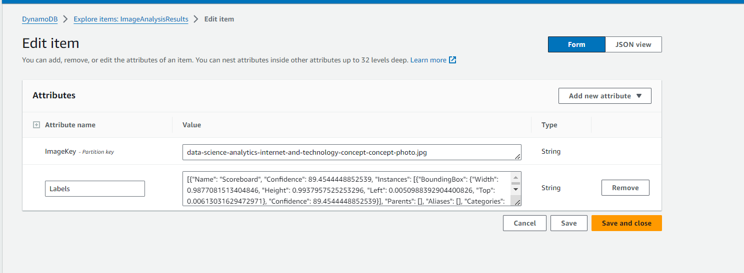

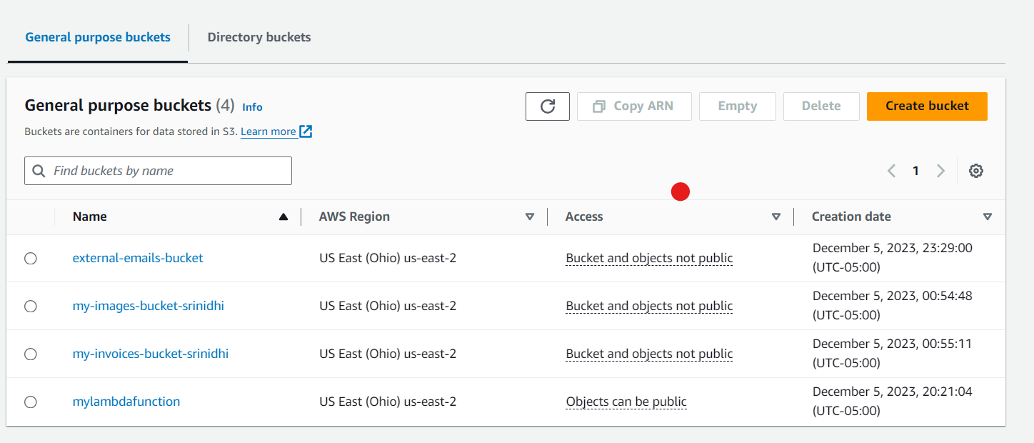

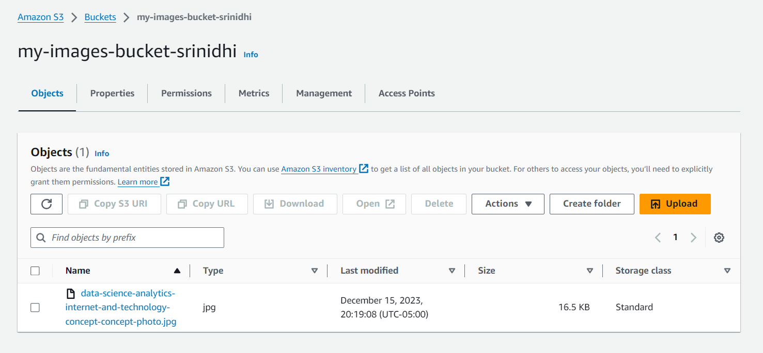

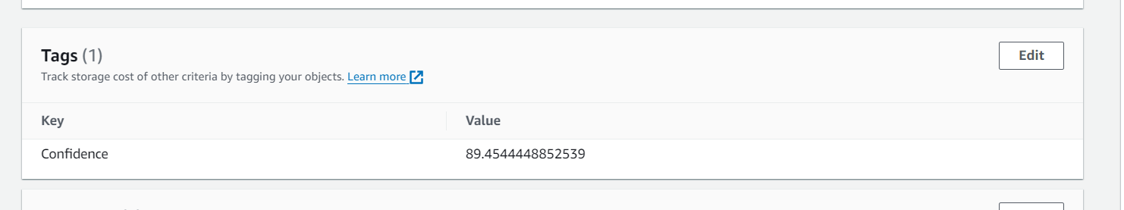

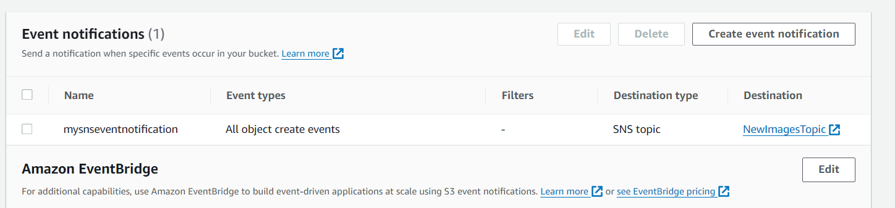

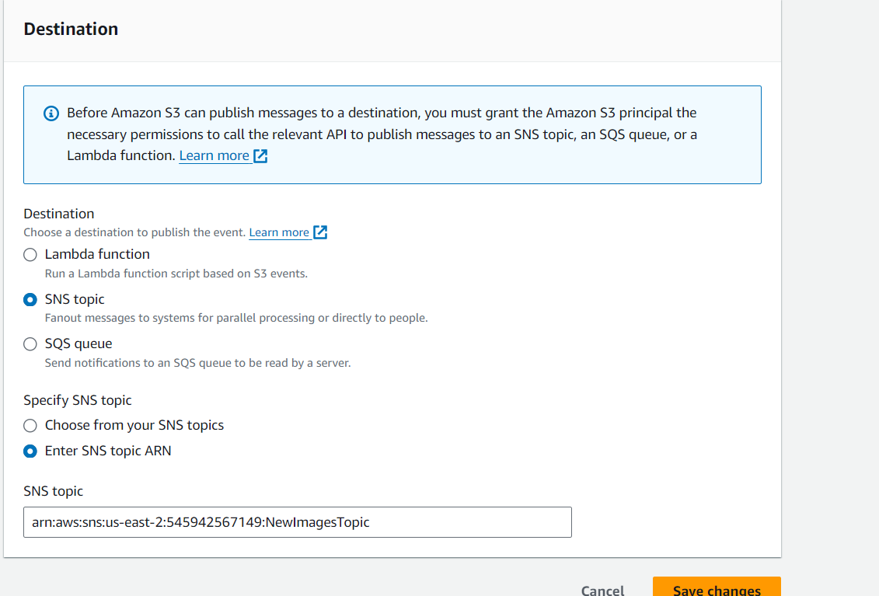

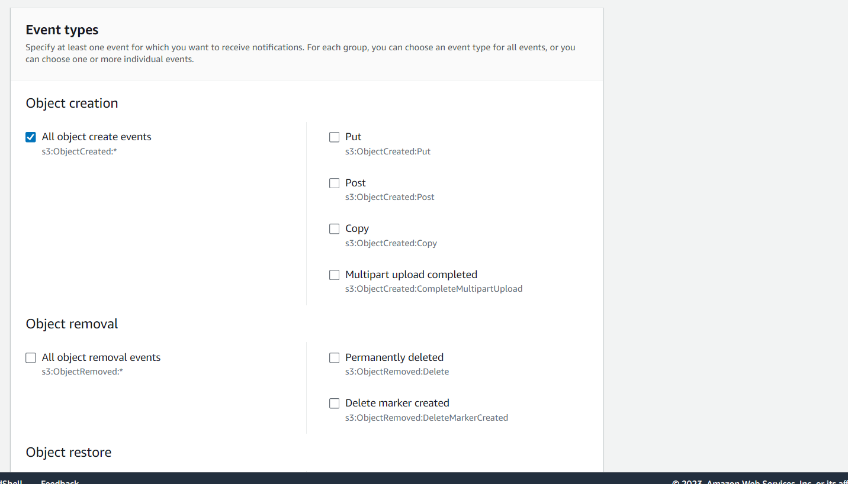

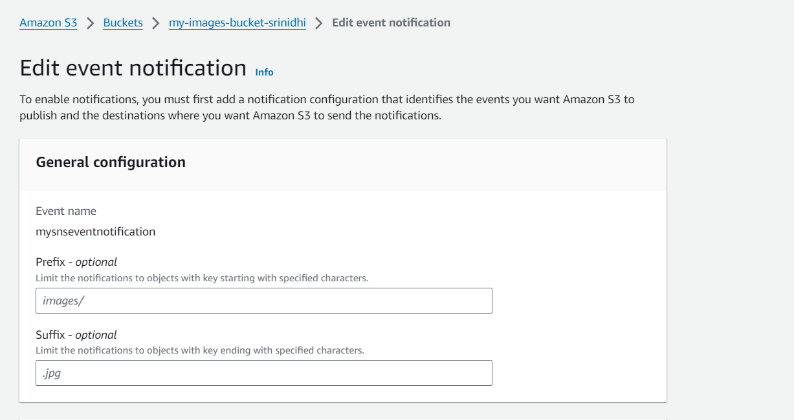

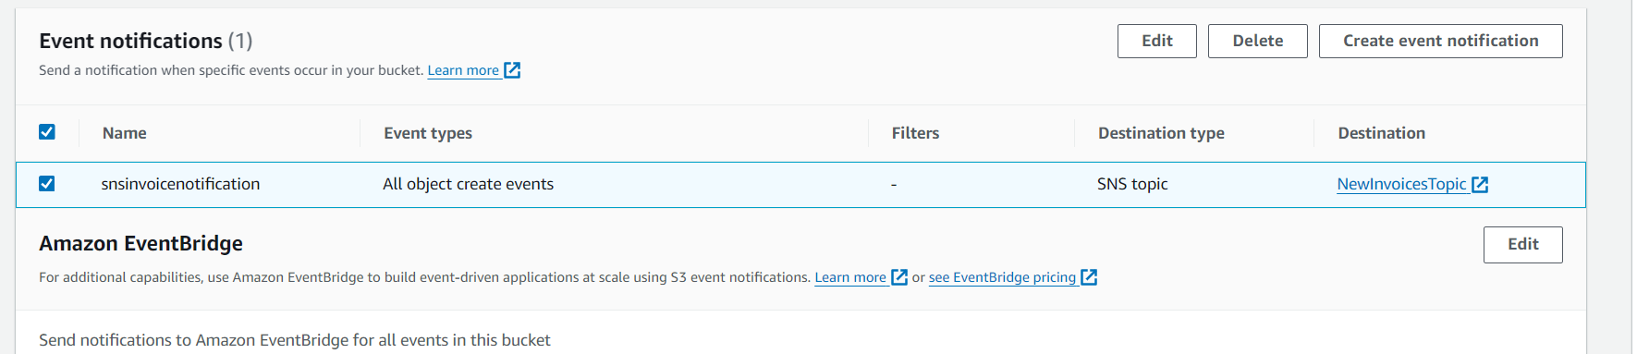

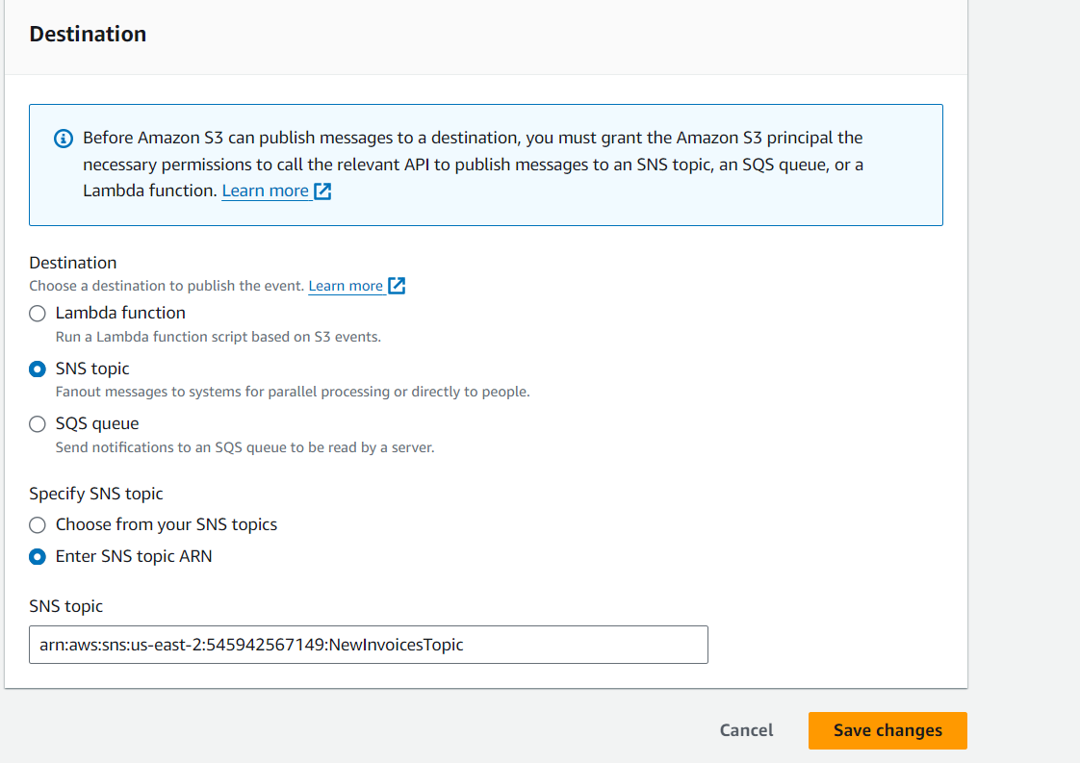

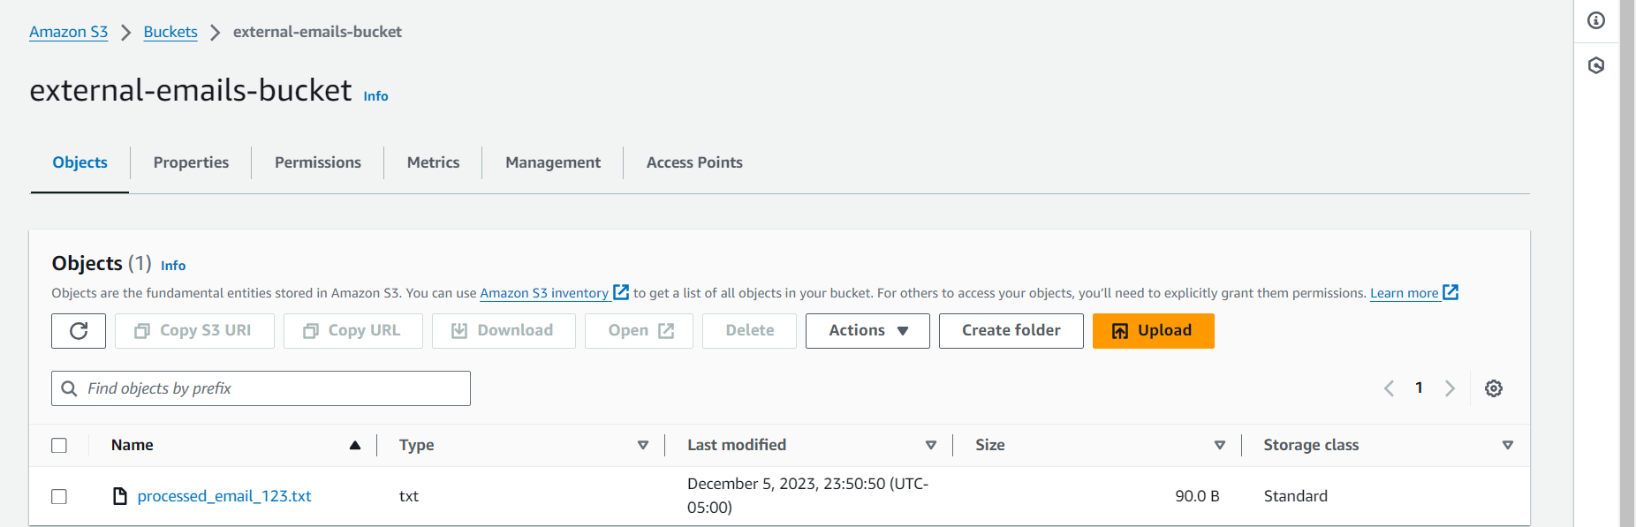

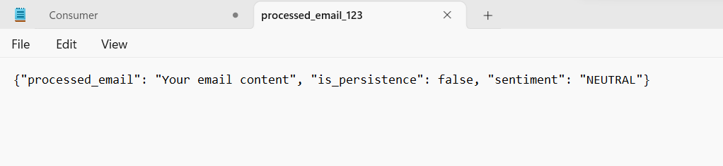

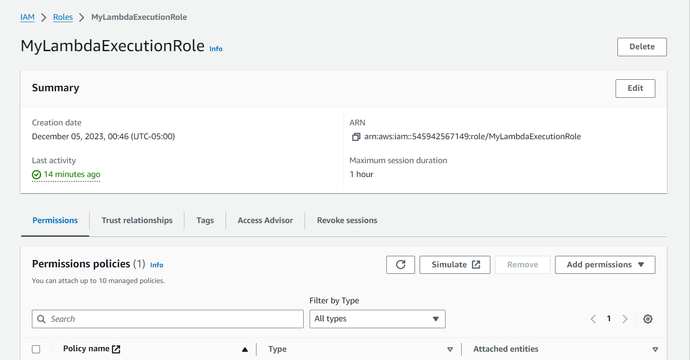

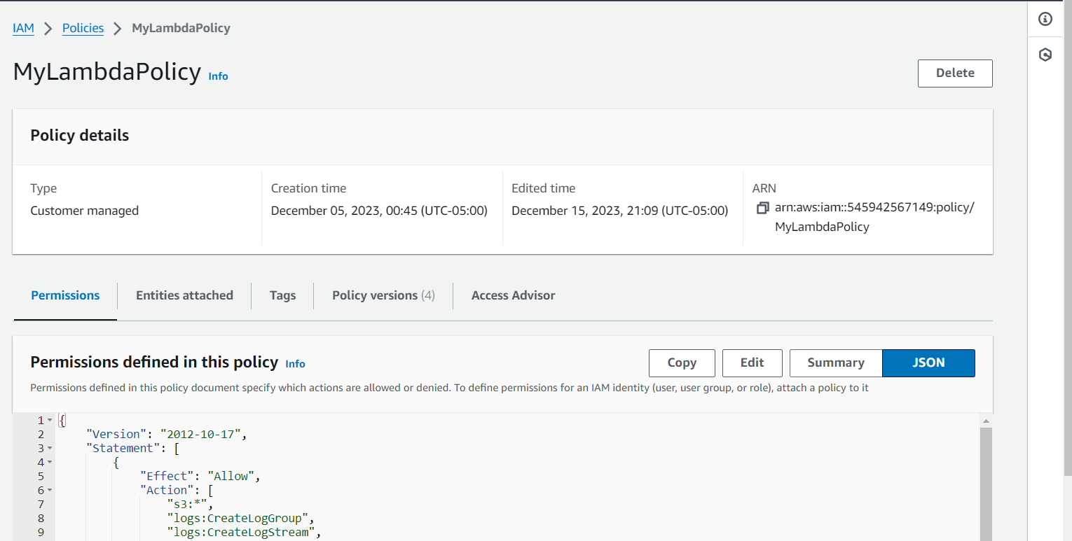

{

"Version": "2012-10-17",

"Statement": [

{

"Effect": "Allow",

"Action": [

"s3:*",

"logs:CreateLogGroup",

"logs:CreateLogStream",

"logs:PutLogEvents",

"sqs:ReceiveMessage",

"sqs:DeleteMessage",

"sqs:GetQueueAttributes",

"rekognition:DetectLabels",

"dynamodb:PutItem",

"comprehend:DetectSentiment",

"textract:StartDocumentTextDetection",

"textract:GetDocumentTextDetection"

],

"Resource": "*"

}

]

}

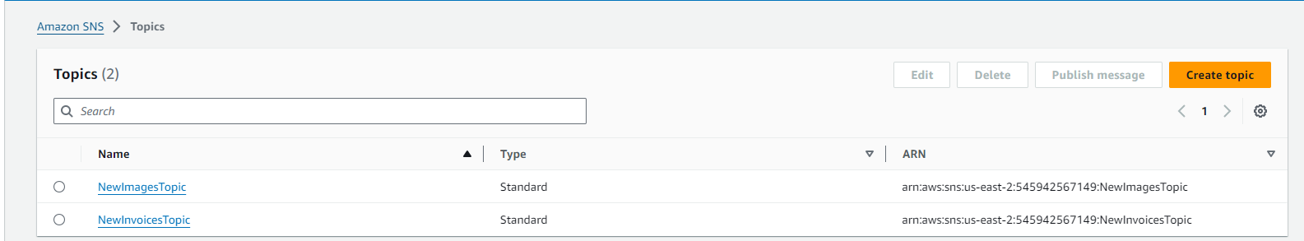

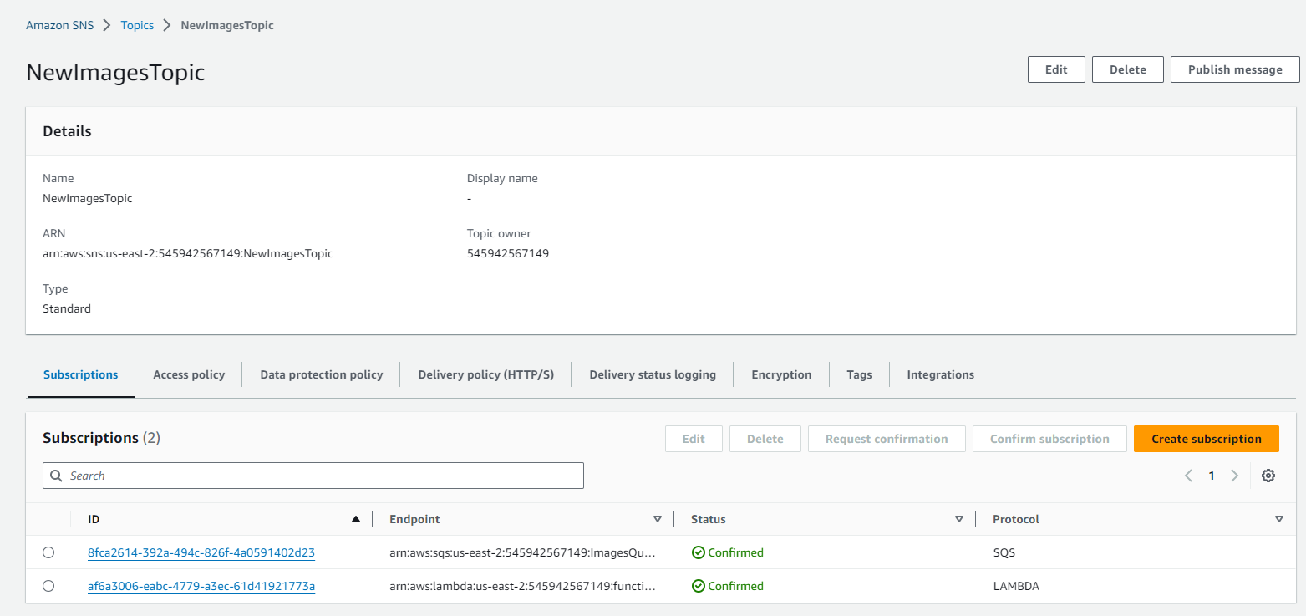

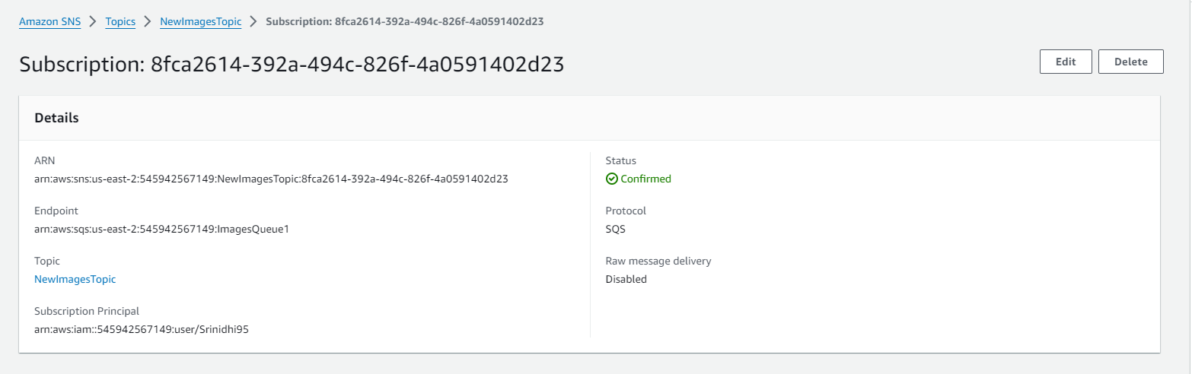

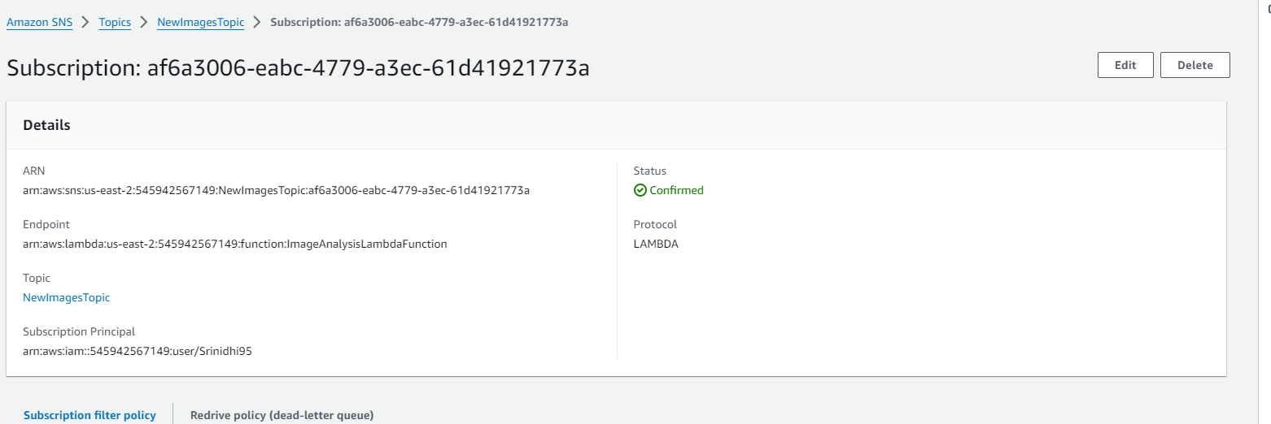

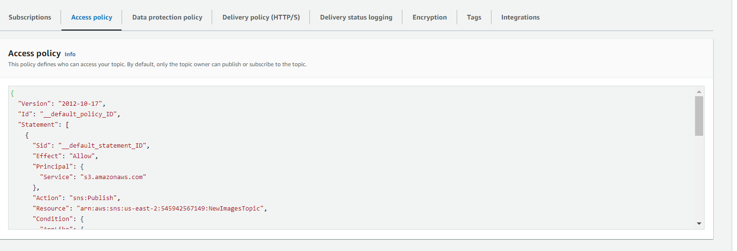

{

"Version": "2012-10-17",

"Id": "__default_policy_ID",

"Statement": [

{

"Sid": "__default_statement_ID",

"Effect": "Allow",

"Principal": {

"Service": "s3.amazonaws.com"

},

"Action": "sns:Publish",

"Resource": "arn:aws:sns:us-east-2:545942567149:NewImagesTopic",

"Condition": {

"ArnLike": {

"aws:SourceArn": "arn:aws:s3:::my-images-bucket-srinidhi"

}

}

},

{

"Sid": "OtherSNSActions",

"Effect": "Allow",

"Principal": {

"AWS": "*"

},

"Action": [

"SNS:GetTopicAttributes",

"SNS:SetTopicAttributes",

"SNS:AddPermission",

"SNS:RemovePermission",

"SNS:DeleteTopic",

"SNS:Subscribe",

"SNS:ListSubscriptionsByTopic"

],

"Resource": "arn:aws:sns:us-east-2:545942567149:NewImagesTopic",

"Condition": {

"StringEquals": {

"AWS:SourceOwner": "545942567149"

}

}

}

]

}

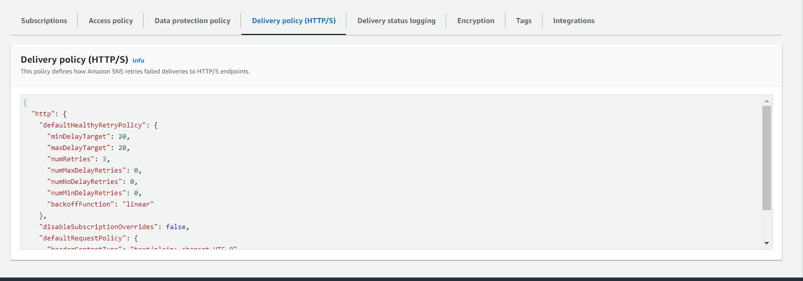

{

"http": {

"defaultHealthyRetryPolicy": {

"minDelayTarget": 20,

"maxDelayTarget": 20,

"numRetries": 3,

"numMaxDelayRetries": 0,

"numNoDelayRetries": 0,

"numMinDelayRetries": 0,

"backoffFunction": "linear"

},

"disableSubscriptionOverrides": false,

"defaultRequestPolicy": {

"headerContentType": "text/plain; charset=UTF-8"

}

}

}

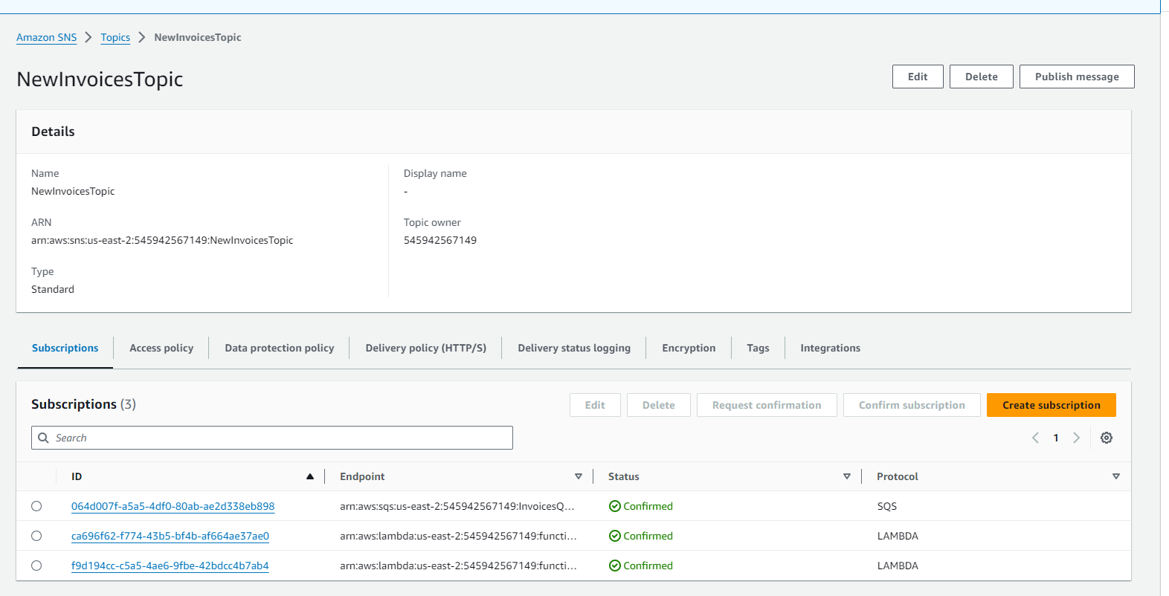

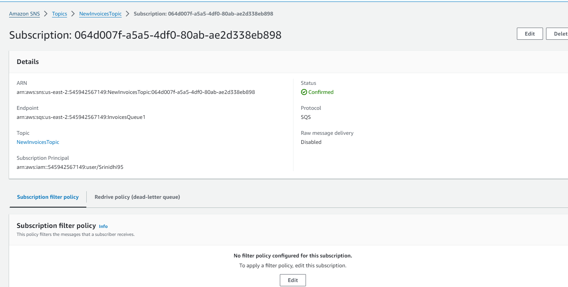

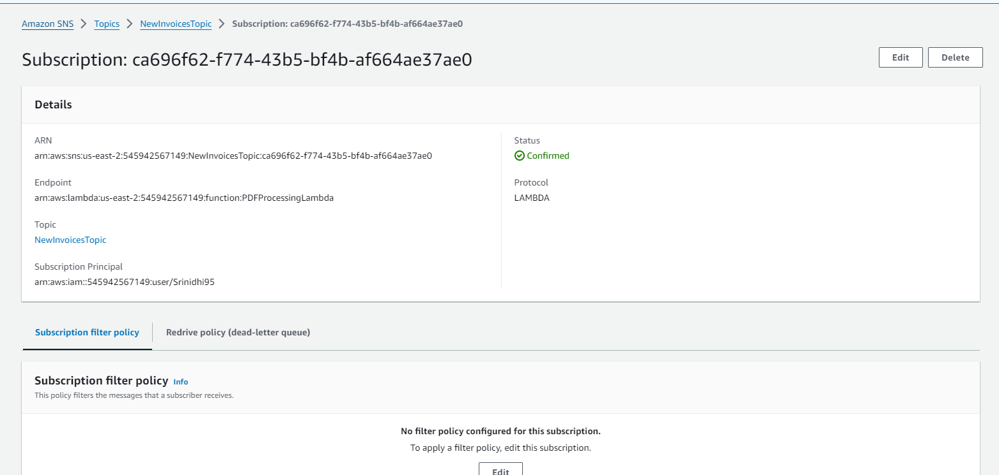

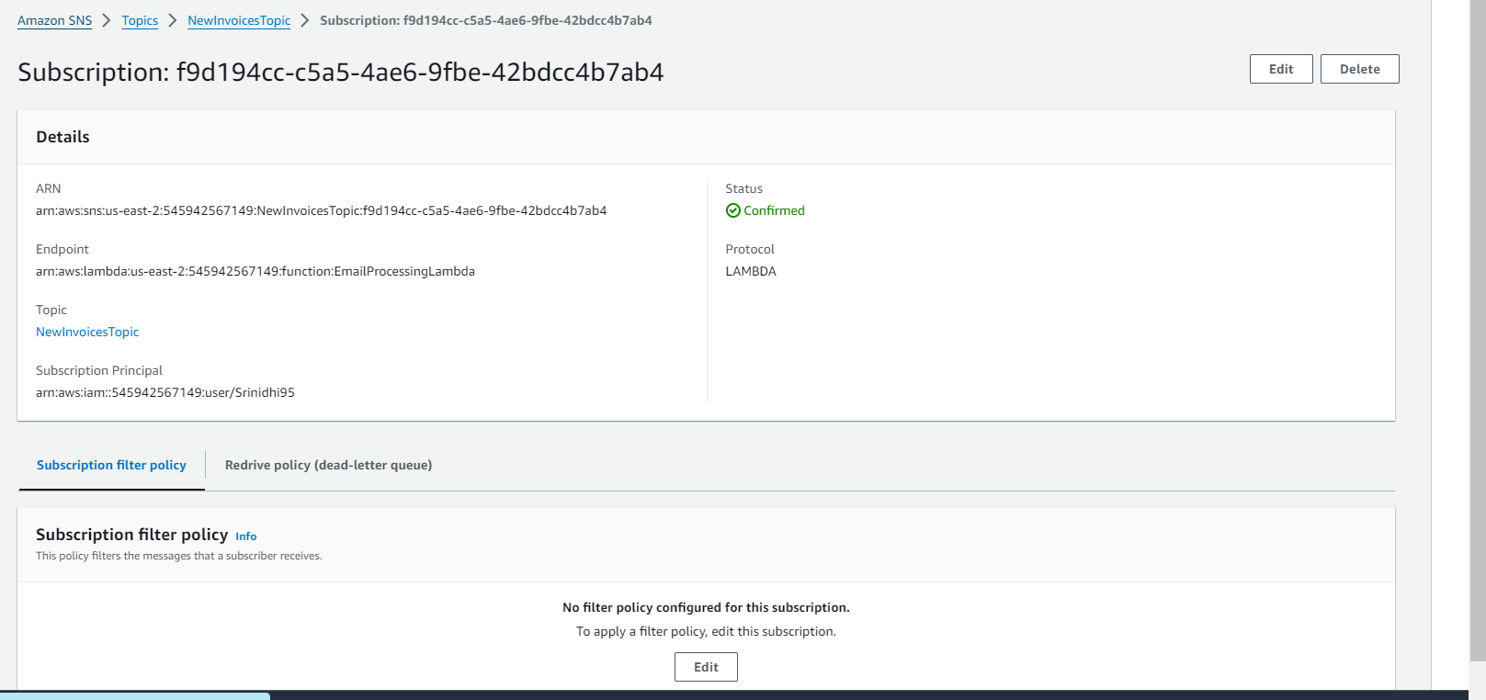

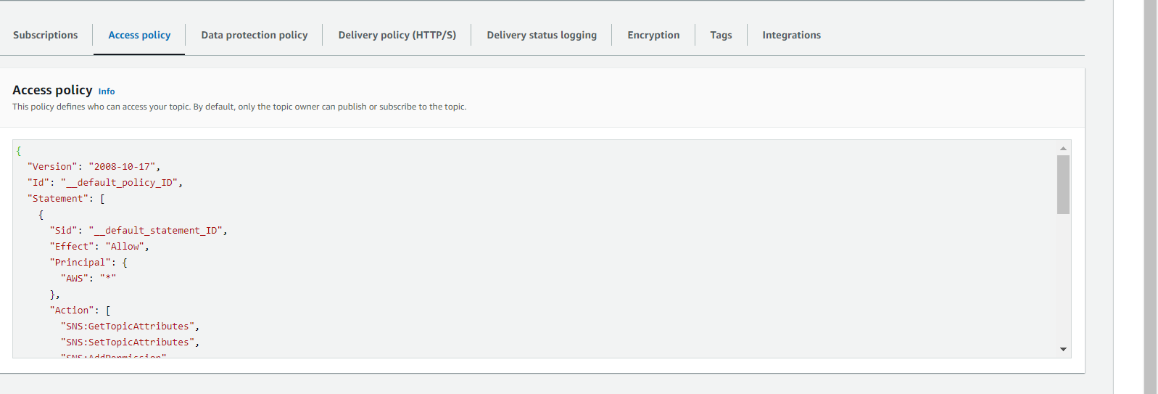

{

"Version": "2008-10-17",

"Id": "__default_policy_ID",

"Statement": [

{

"Sid": "__default_statement_ID",

"Effect": "Allow",

"Principal": {

"AWS": "*"

},

"Action": [

"SNS:GetTopicAttributes",

"SNS:SetTopicAttributes",

"SNS:AddPermission",

"SNS:RemovePermission",

"SNS:DeleteTopic",

"SNS:Subscribe",

"SNS:ListSubscriptionsByTopic",

"SNS:Publish"

],

"Resource": "arn:aws:sns:us-east-2:545942567149:NewInvoicesTopic",

"Condition": {

"StringEquals": {

"AWS:SourceOwner": "545942567149"

}

}

},

{

"Sid": "AllowS3BucketPublish",

"Effect": "Allow",

"Principal": {

"Service": "s3.amazonaws.com"

},

"Action": "sns:Publish",

"Resource": "arn:aws:sns:us-east-2:545942567149:NewInvoicesTopic",

"Condition": {

"ArnLike": {

"aws:SourceArn": "arn:aws:s3:::my-invoices-bucket-srinidhi"

}

}

}

]

}

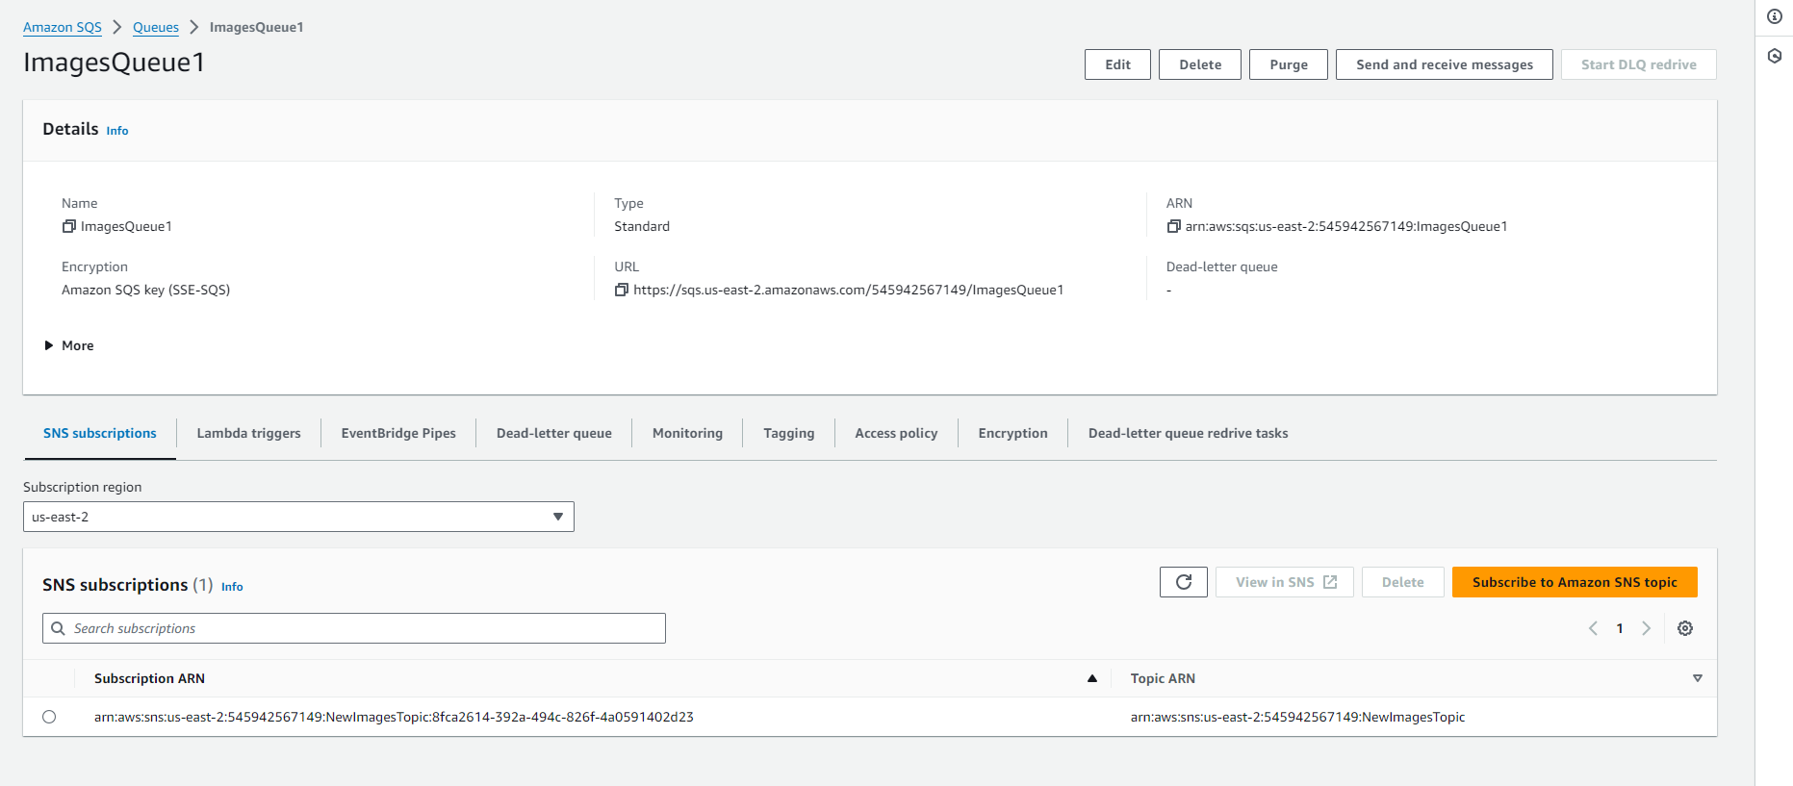

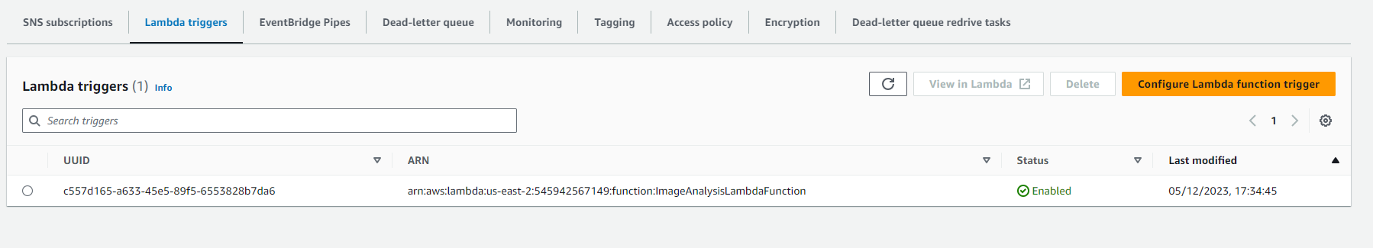

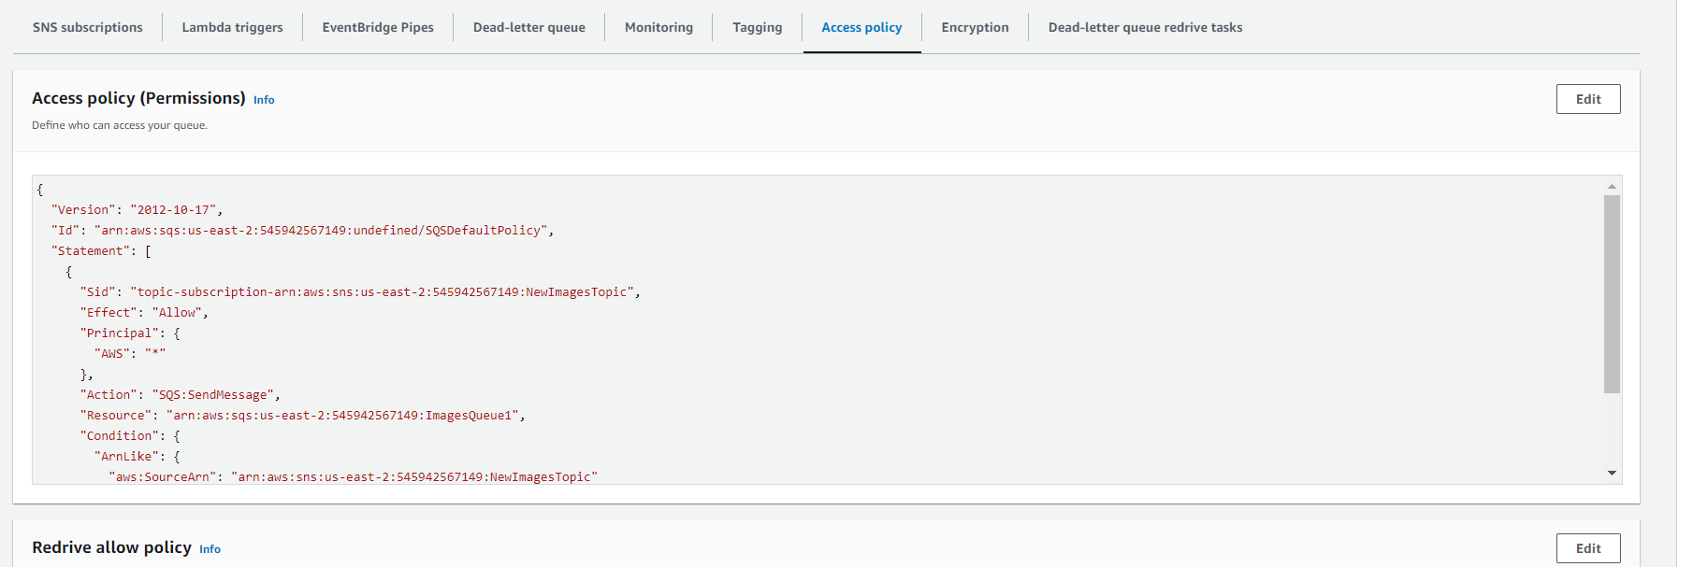

{

 "Version": "2012-10-17",

 "Id": "arn:aws:sqs:us-east-2:545942567149:undefined/SQSDefaultPolicy",

 "Statement": [

  {

     "Sid": "topic-subscription-arn:aws:sns:us-east-2:545942567149:NewImagesTopic",

     "Effect": "Allow",

     "Principal": {

       "AWS": "*"

    },

     "Action": "SQS:SendMessage",

     "Resource": "arn:aws:sqs:us-east-2:545942567149:ImagesQueue1",

     "Condition": {

       "ArnLike": {

         "aws:SourceArn": "arn:aws:sns:us-east-2:545942567149:NewImagesTopic"

      }

    }

  }

]

}

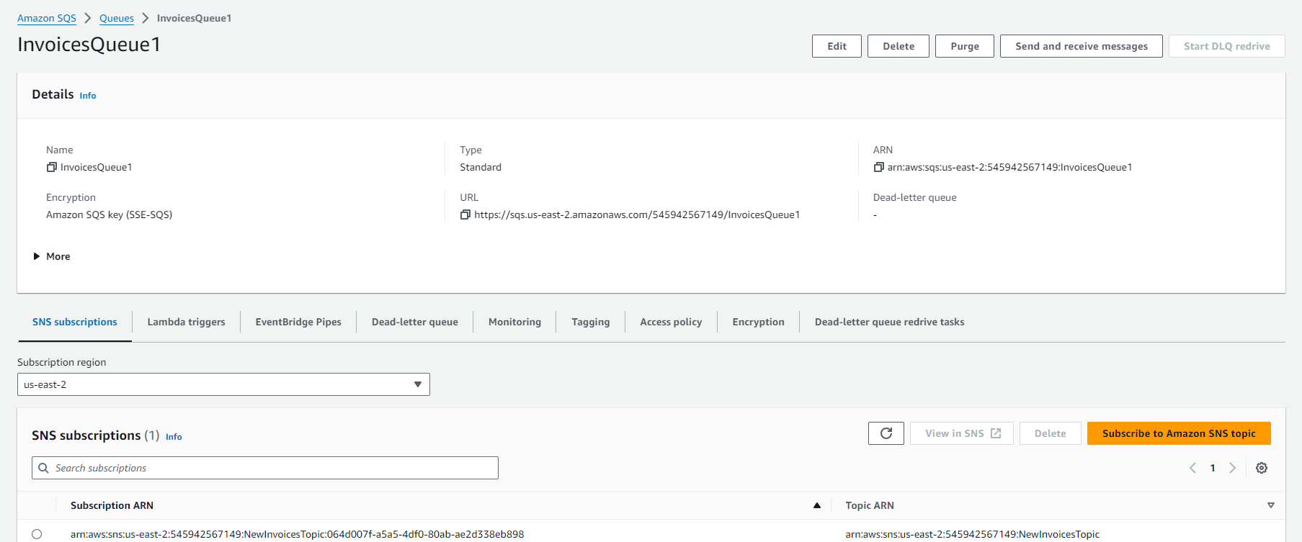

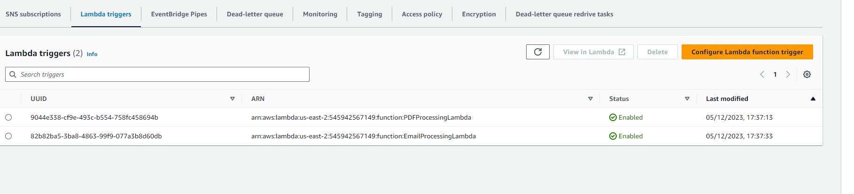

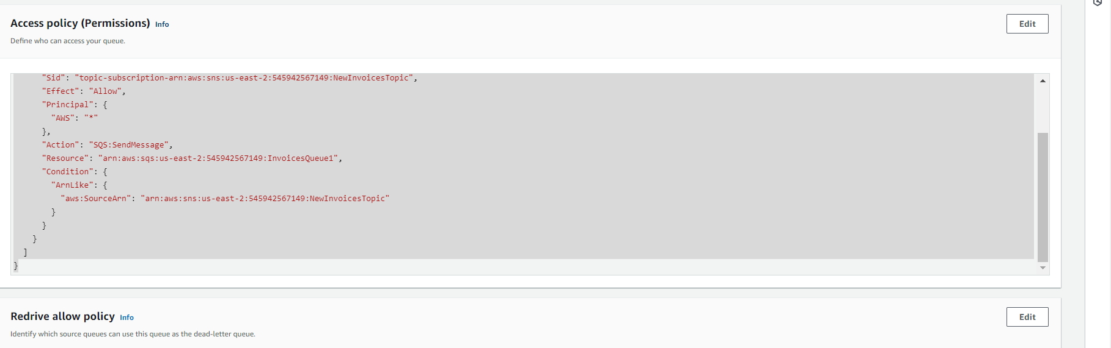

{

"Version": "2012-10-17",

"Id": "arn:aws:sqs:us-east-2:545942567149:undefined/SQSDefaultPolicy",

"Statement": [

{

"Sid": "topic-subscription-arn:aws:sns:us-east-2:545942567149:NewInvoicesTopic",

"Effect": "Allow",

"Principal": {

"AWS": "*"

},

"Action": "SQS:SendMessage",

"Resource": "arn:aws:sqs:us-east-2:545942567149:InvoicesQueue1",

"Condition": {

"ArnLike": {

"aws:SourceArn": "arn:aws:sns:us-east-2:545942567149:NewInvoicesTopic"

}

}

}

]

}

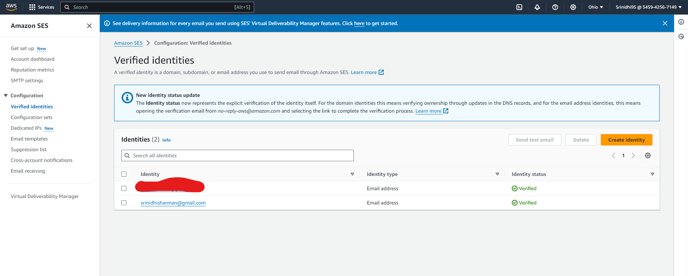

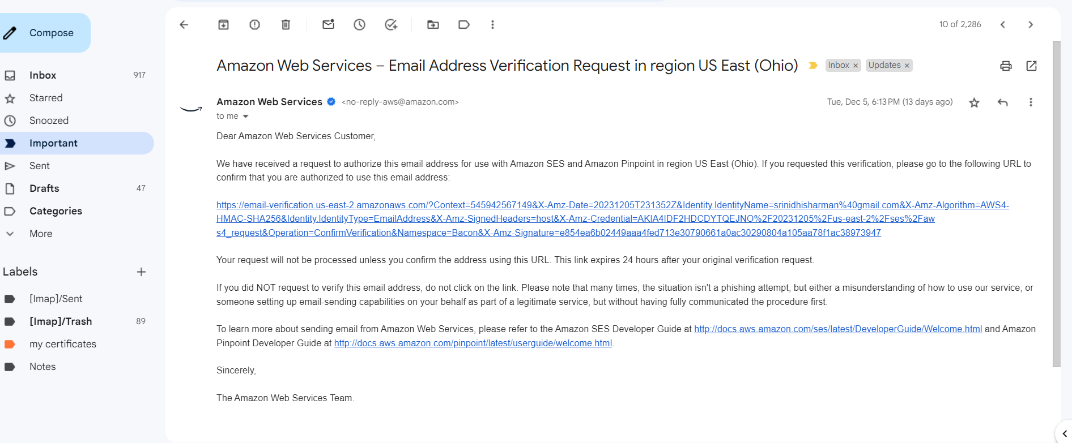

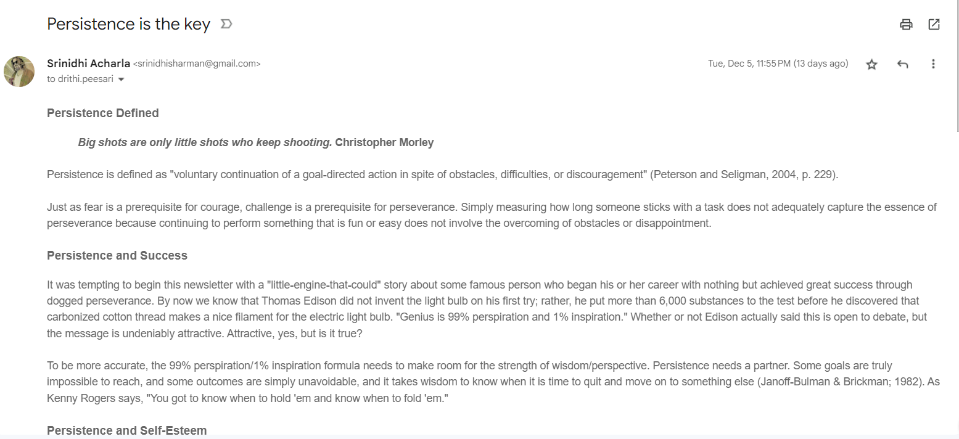

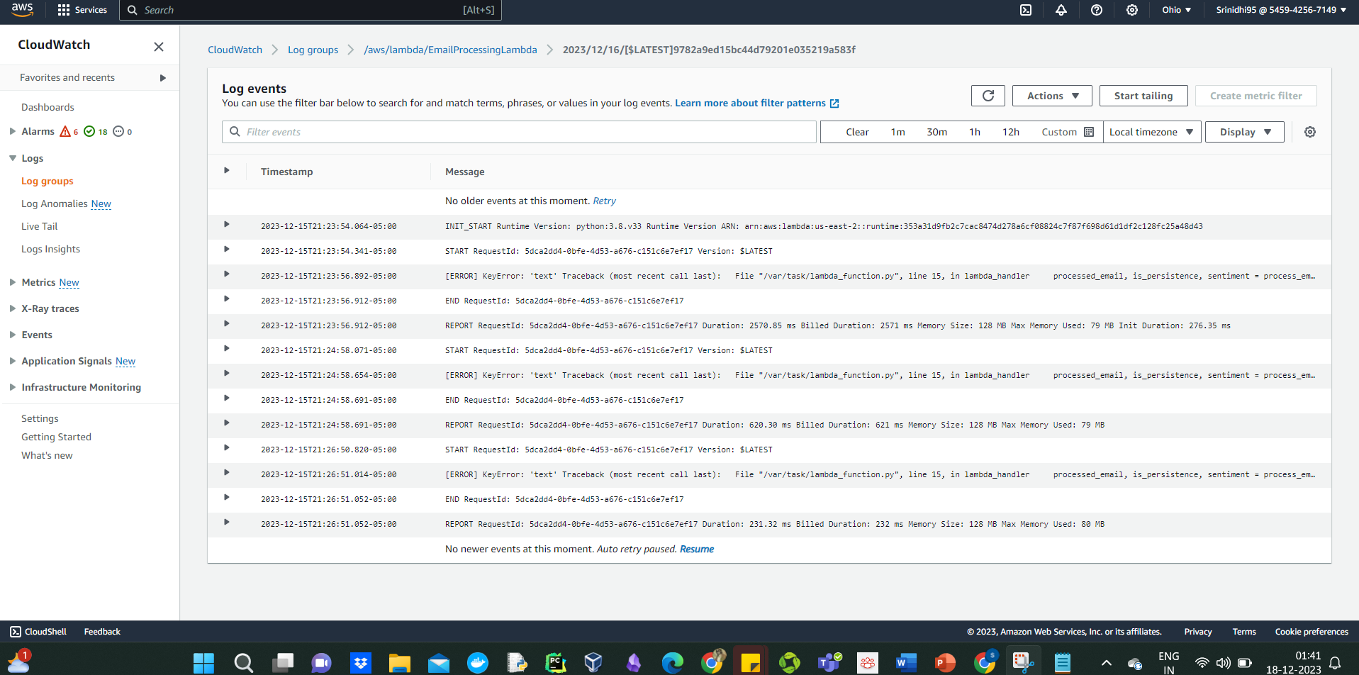

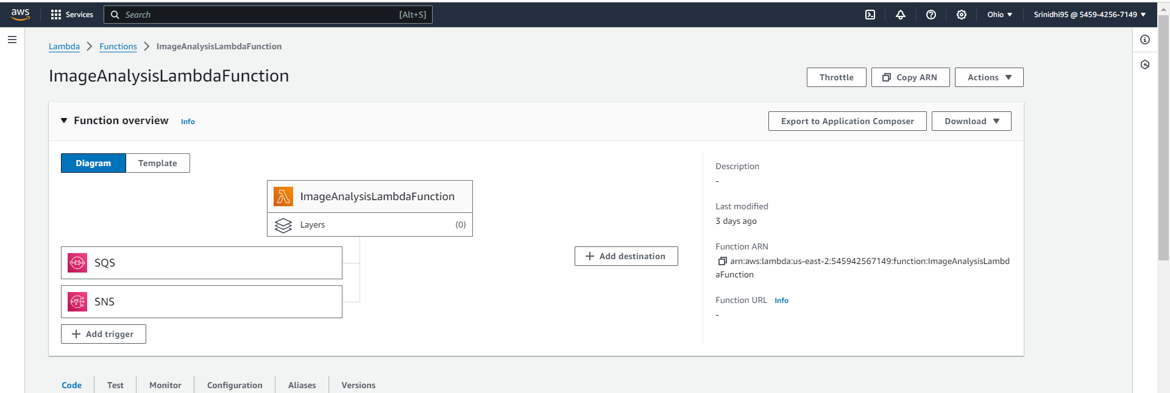

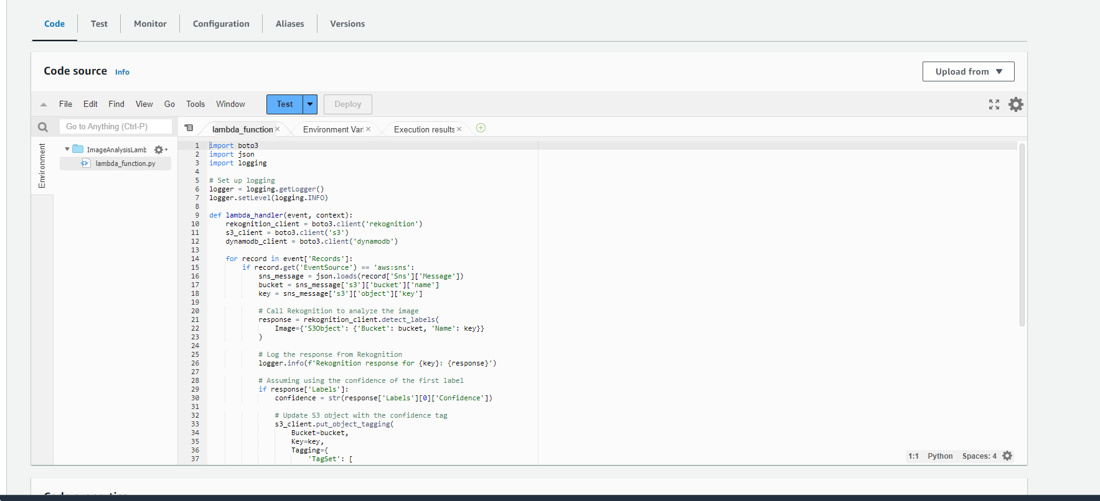

import boto3

import json

import logging

# Set up logging

logger = logging.getLogger()

logger.setLevel(logging.INFO)

def lambda_handler(event, context):

rekognition_client = boto3.client('rekognition')

s3_client = boto3.client('s3')

dynamodb_client = boto3.client('dynamodb')

for record in event['Records']:

if record.get('EventSource') == 'aws:sns':

sns_message = json.loads(record['Sns']['Message'])

bucket = sns_message['s3']['bucket']['name']

key = sns_message['s3']['object']['key']

# Call Rekognition to analyze the image

response = rekognition_client.detect_labels(

Image={'S3Object': {'Bucket': bucket, 'Name': key}}

)

# Log the response from Rekognition

logger.info(f'Rekognition response for {key}: {response}')

# Assuming using the confidence of the first label

if response['Labels']:

confidence = str(response['Labels'][0]['Confidence'])

# Update S3 object with the confidence tag

s3_client.put_object_tagging(

Bucket=bucket,

Key=key,

Tagging={

'TagSet': [

{

'Key': 'Confidence',

'Value': confidence

}

]

}

)

# Prepare the item to put in DynamoDB

item = {

'ImageKey': {'S': key},

'Labels': {'S': json.dumps(response['Labels'])}

}

# Log the item to be put in DynamoDB

logger.info(f'Item to be put in DynamoDB: {item}')

# Store the analysis results in DynamoDB

dynamodb_client.put_item(

TableName='ImageAnalysisResults',

Item=item

)

return {

'statusCode': 200,

'body': json.dumps('Image analysis complete')

}

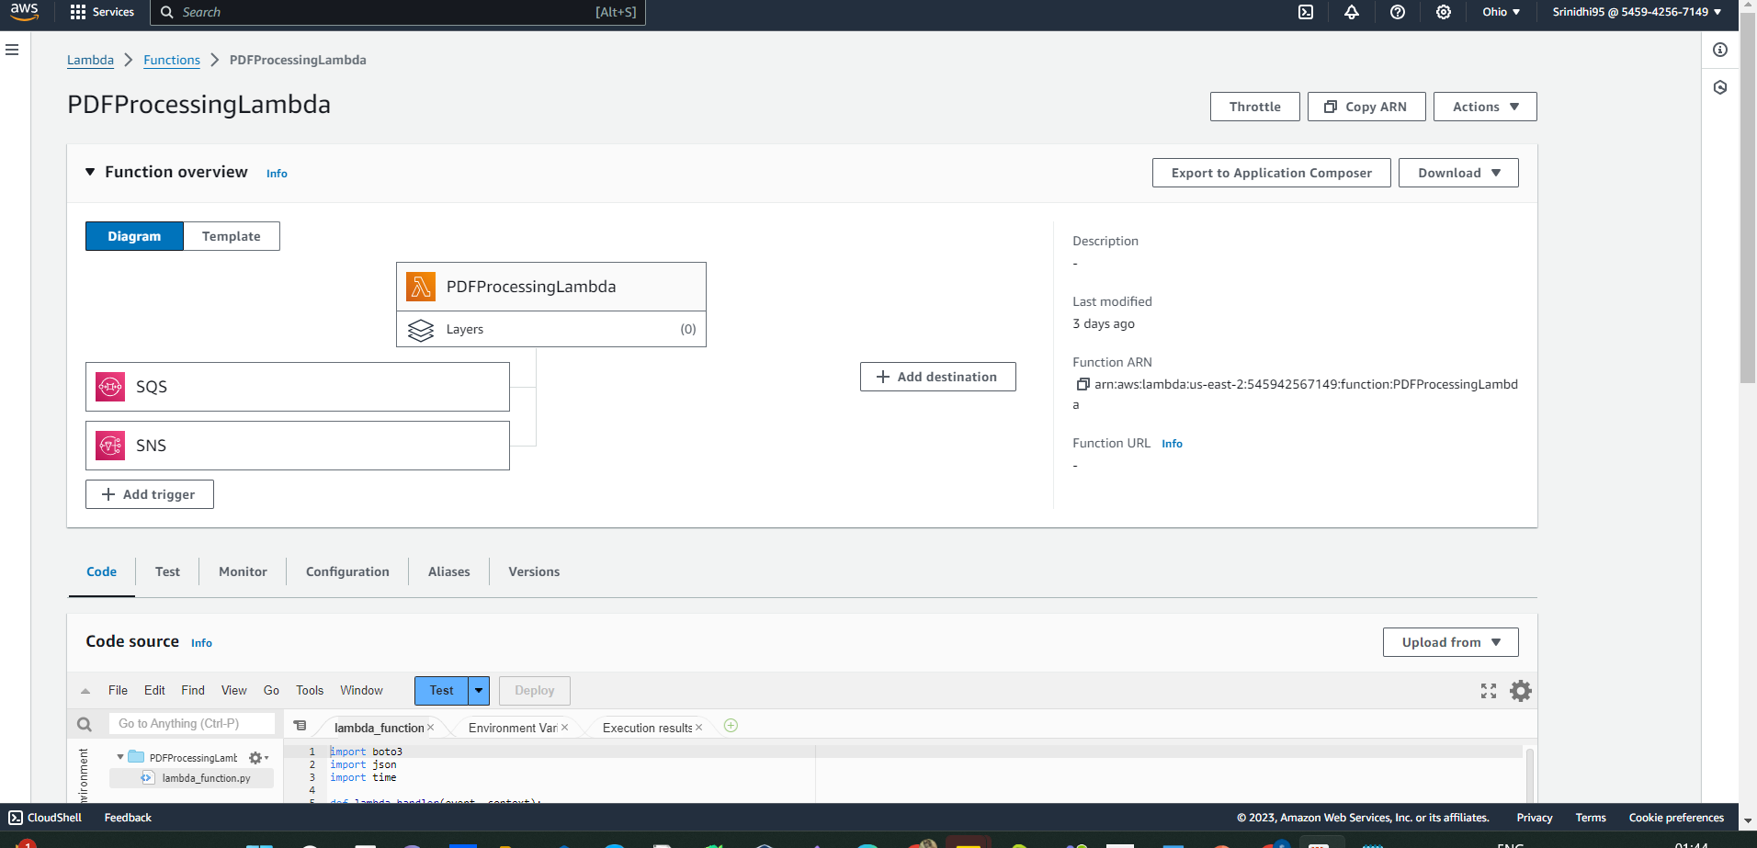

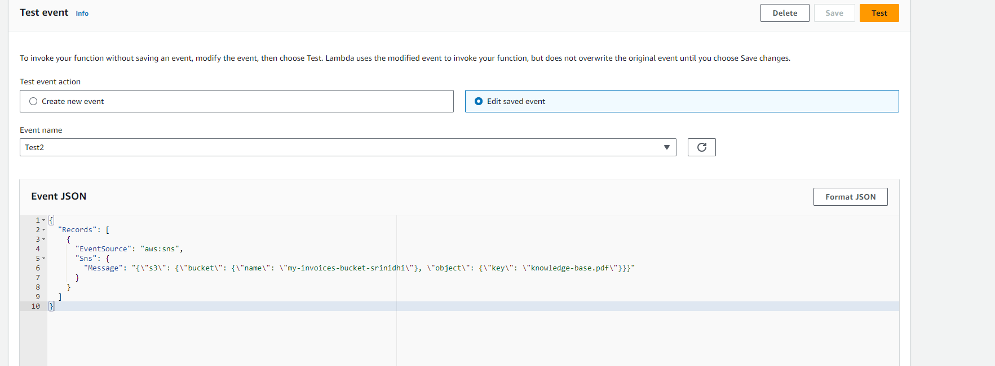

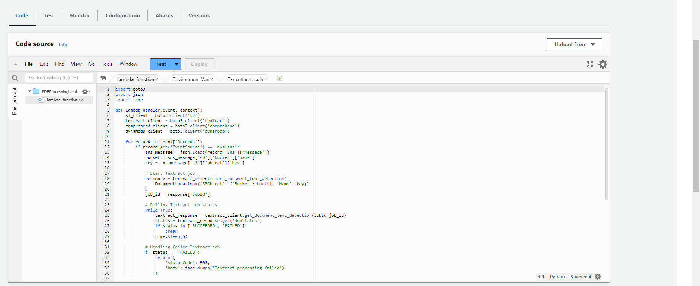

import boto3

import json

import time

def lambda_handler(event, context):

s3_client = boto3.client('s3')

textract_client = boto3.client('textract')

comprehend_client = boto3.client('comprehend')

dynamodb_client = boto3.client('dynamodb')

for record in event['Records']:

if record.get('EventSource') == 'aws:sns':

sns_message = json.loads(record['Sns']['Message'])

bucket = sns_message['s3']['bucket']['name']

key = sns_message['s3']['object']['key']

# Start Textract job

response = textract_client.start_document_text_detection(

DocumentLocation={'S3Object': {'Bucket': bucket, 'Name': key}}

)

job_id = response['JobId']

# Polling Textract job status

while True:

textract_response = textract_client.get_document_text_detection(JobId=job_id)

status = textract_response.get('JobStatus')

if status in ['SUCCEEDED', 'FAILED']:

break

time.sleep(5)

# Handling failed Textract job

if status == 'FAILED':

return {

'statusCode': 500,

'body': json.dumps('Textract processing failed')

}

# Extract text from Textract response

extracted_text = ' '.join([block['Text'] for block in textract_response['Blocks'] if block['BlockType'] == 'LINE'])

# Perform sentiment analysis

sentiment_response = comprehend_client.detect_sentiment(

Text=extracted_text[:5000], # Comprehend supports up to 5000 bytes per request

LanguageCode='en'

)

contains_s3 = 's3' in extracted_text.lower()

# Storing results in DynamoDB

dynamodb_client.put_item(

TableName='ProcessedEmails',

Item={

'PersistenceKeyword': {'S': key}, # Assuming 'key' as the primary key value

'Sentiment': {'S': sentiment_response['Sentiment']},

'SentimentScore': {'S': json.dumps(sentiment_response['SentimentScore'])},

'ContainsS3': {'BOOL': contains_s3}

}

)

return {

'statusCode': 200,

'body': json.dumps('PDF processing complete')

}

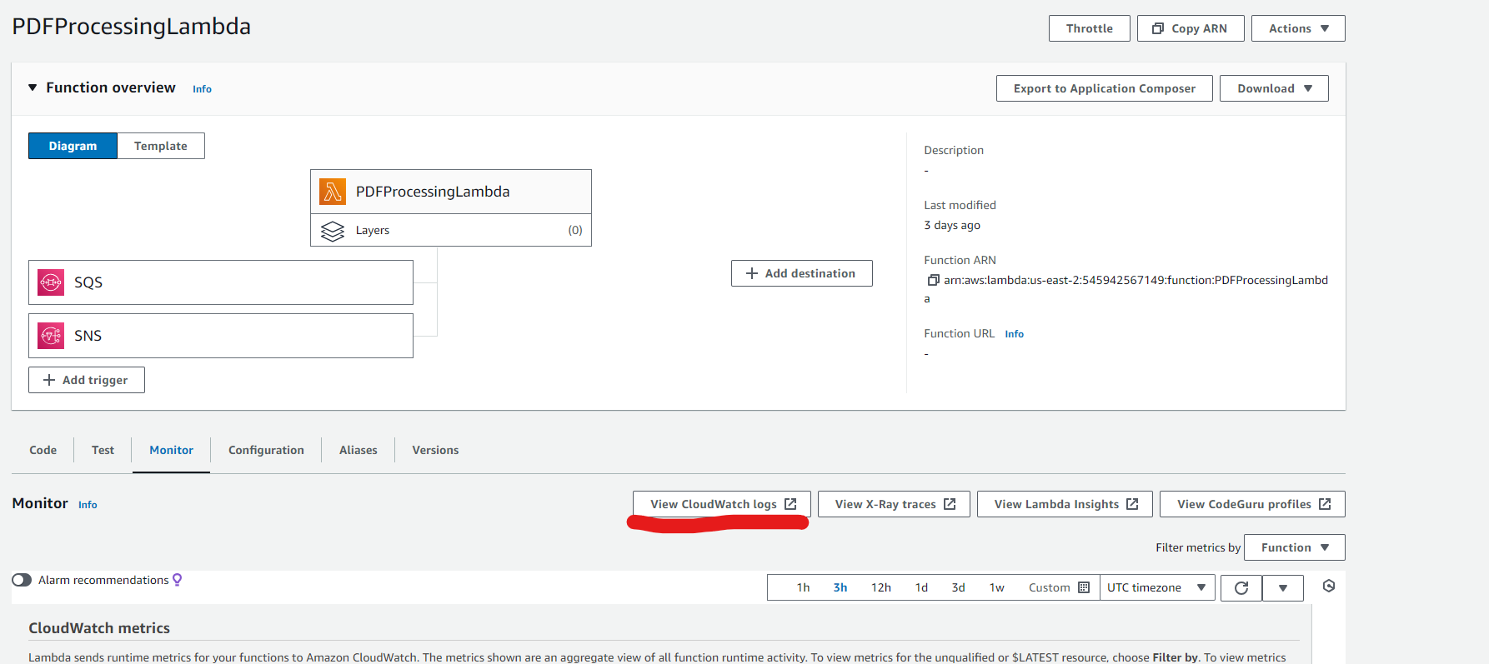

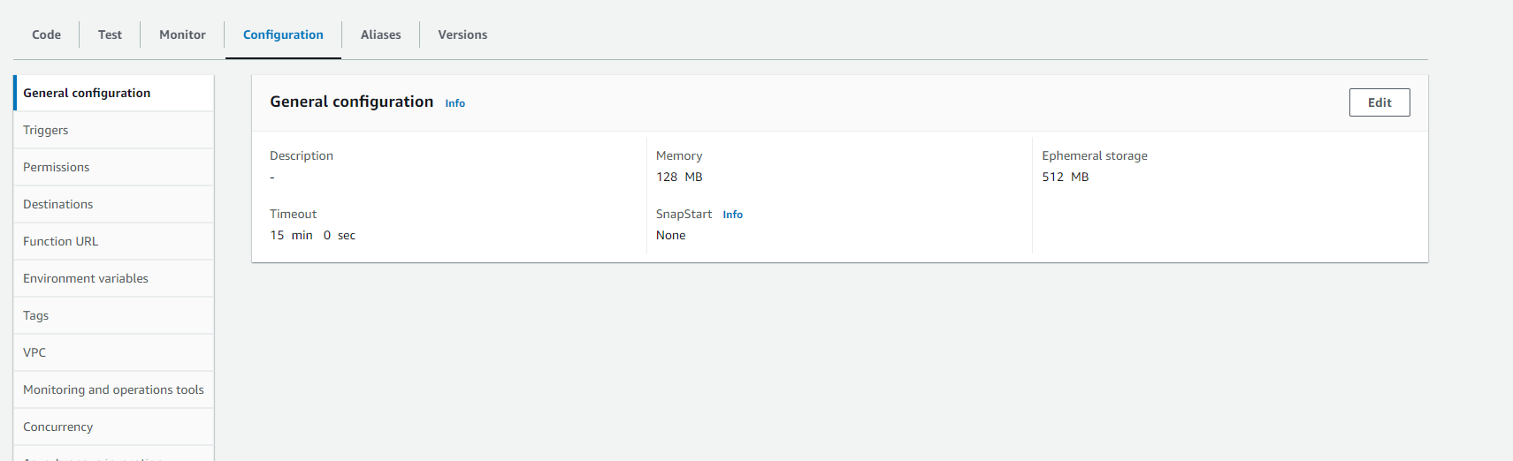

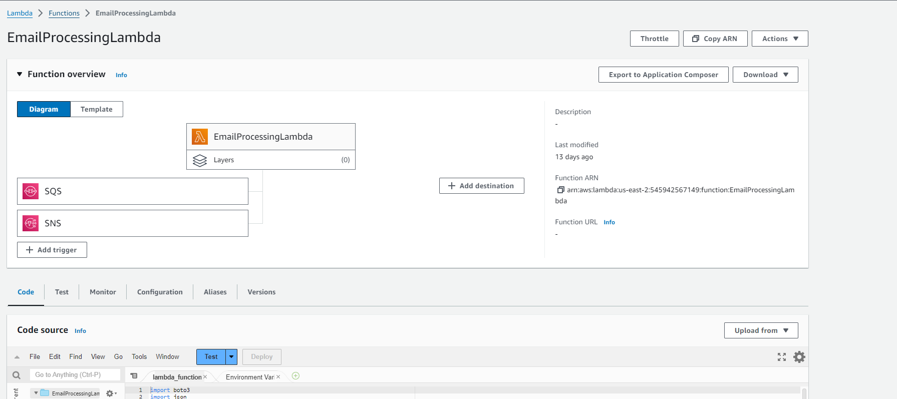

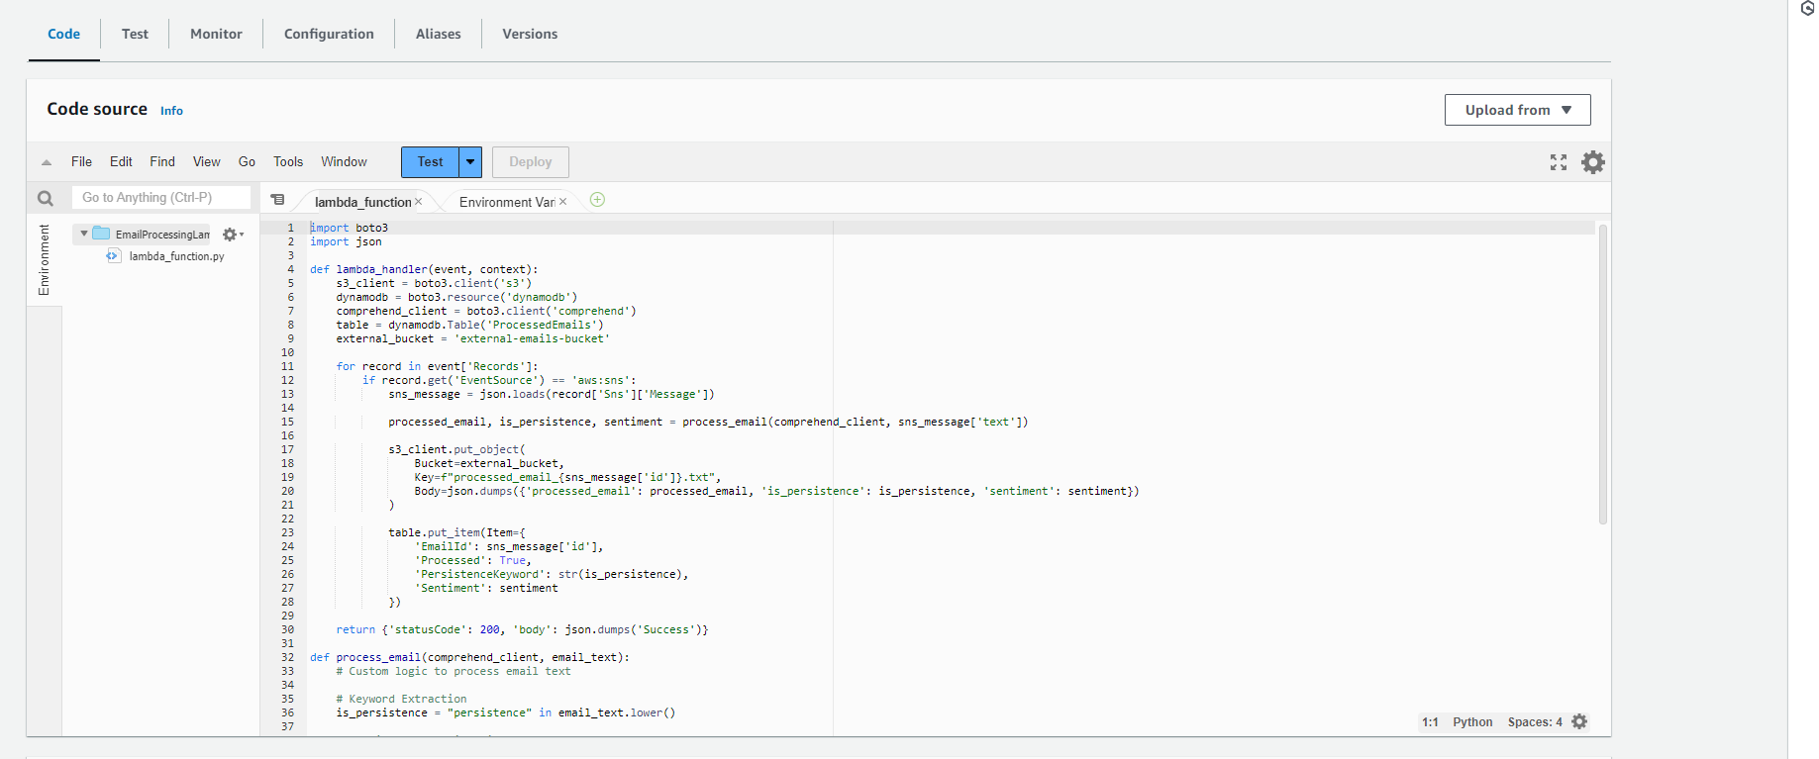

import boto3

import json

def lambda_handler(event, context):

s3_client = boto3.client('s3')

dynamodb = boto3.resource('dynamodb')

comprehend_client = boto3.client('comprehend')

table = dynamodb.Table('ProcessedEmails')

external_bucket = 'external-emails-bucket'

for record in event['Records']:

if record.get('EventSource') == 'aws:sns':

sns_message = json.loads(record['Sns']['Message'])

processed_email, is_persistence, sentiment = process_email(comprehend_client, sns_message['text'])

s3_client.put_object(

Bucket=external_bucket,

Key=f"processed_email_{sns_message['id']}.txt",

Body=json.dumps({'processed_email': processed_email, 'is_persistence': is_persistence, 'sentiment': sentiment})

)

table.put_item(Item={

'EmailId': sns_message['id'],

'Processed': True,

'PersistenceKeyword': str(is_persistence),

'Sentiment': sentiment

})

return {'statusCode': 200, 'body': json.dumps('Success')}

def process_email(comprehend_client, email_text):

# Custom logic to process email text

# Keyword Extraction

is_persistence = "persistence" in email_text.lower()

# Sentiment Analysis using AWS Comprehend

sentiment = analyze_sentiment(comprehend_client, email_text)

return email_text, is_persistence, sentiment

def analyze_sentiment(comprehend_client, text):

response = comprehend_client.detect_sentiment(Text=text, LanguageCode='en')

sentiment = response['Sentiment']

return sentiment

# Example usage for testing with SNS-like event

if __name__ == "__main__":

example_email = "This project requires persistence and hard work. We're making great progress!"

test_event = {

'Records': [

{

'EventSource': 'aws:sns',

'Sns': {

'Message': json.dumps({'text': example_email, 'id': '123'})

}

}

]

}

print(lambda_handler(test_event, None))

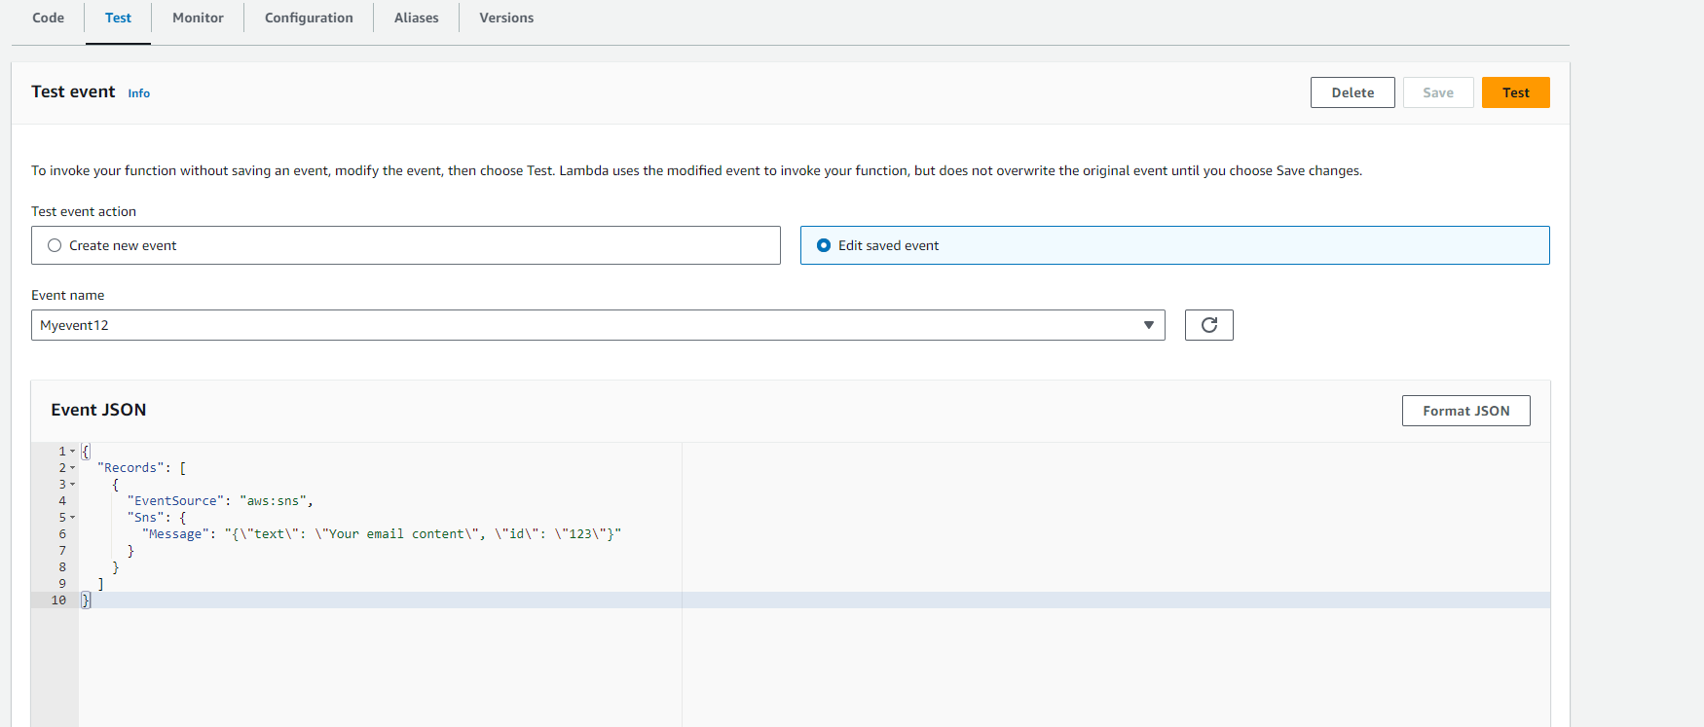

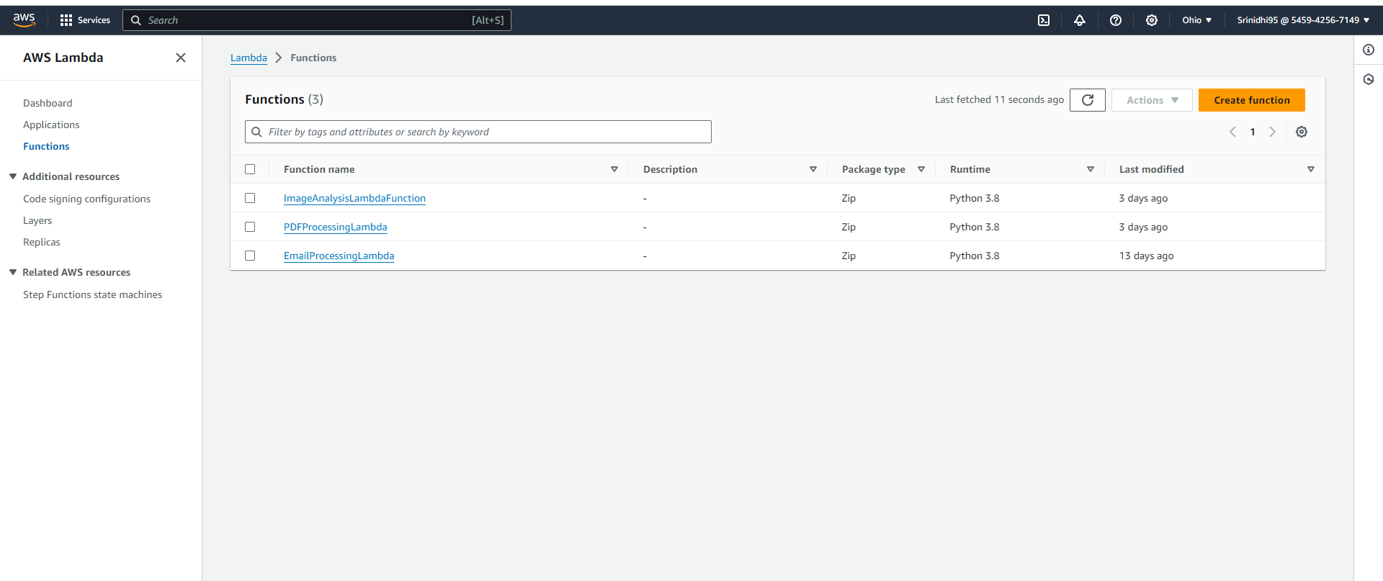

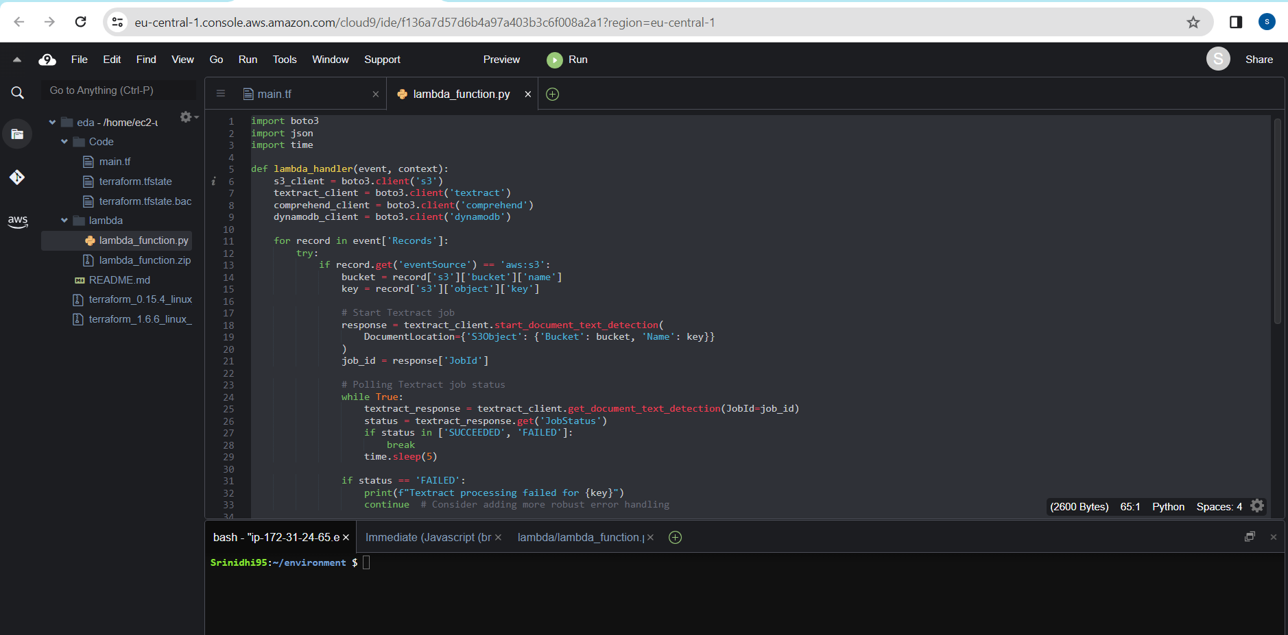

import boto3

import json

import time

def lambda_handler(event, context):

s3_client = boto3.client('s3')

textract_client = boto3.client('textract')

comprehend_client = boto3.client('comprehend')

dynamodb_client = boto3.client('dynamodb')

for record in event['Records']:

try:

if record.get('eventSource') == 'aws:s3':

bucket = record['s3']['bucket']['name']

key = record['s3']['object']['key']

# Start Textract job

response = textract_client.start_document_text_detection(

DocumentLocation={'S3Object': {'Bucket': bucket, 'Name': key}}

)

job_id = response['JobId']

# Polling Textract job status

while True:

textract_response = textract_client.get_document_text_detection(JobId=job_id)

status = textract_response.get('JobStatus')

if status in ['SUCCEEDED', 'FAILED']:

break

time.sleep(5)

if status == 'FAILED':

print(f"Textract processing failed for {key}")

continue # Consider adding more robust error handling

# Extract text from Textract response

extracted_text = ' '.join([block['Text'] for block in textract_response['Blocks'] if block['BlockType'] == 'LINE'])

# Perform sentiment analysis

sentiment_response = comprehend_client.detect_sentiment(

Text=extracted_text[:5000], # Comprehend supports up to 5000 bytes per request

LanguageCode='en'

)

contains_s3 = 's3' in extracted_text.lower()

# Storing results in DynamoDB

dynamodb_client.put_item(

TableName='pdf-metadata', # Ensure this matches your DynamoDB table name

Item={

'id': {'S': key}, # Adjust the primary key field as per your table's schema

'Sentiment': {'S': sentiment_response['Sentiment']},

'SentimentScore': {'S': json.dumps(sentiment_response['SentimentScore'])},

'ContainsS3': {'BOOL': contains_s3}

}

)

except Exception as e:

# Log the error

print(f"Error processing record {record}: {str(e)}")

return {

'statusCode': 200,

'body': json.dumps('PDF processing complete')

}

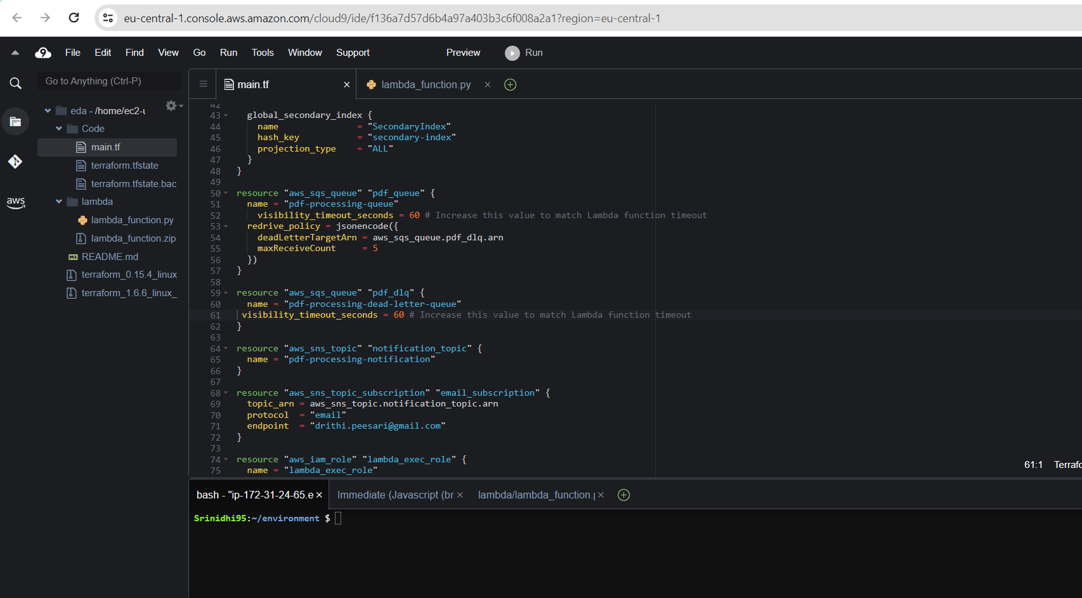

provider "aws" {

region = "eu-central-1" # Set the desired region for all resources

}

resource "aws_s3_bucket" "pdf_bucket" {

bucket = "pdf-processing-bucket-srinidhi"

}

resource "aws_s3_bucket_versioning" "pdf_bucket_versioning" {

bucket = aws_s3_bucket.pdf_bucket.id

versioning_configuration {

status = "Enabled"

}

}

resource "aws_s3_bucket_server_side_encryption_configuration" "pdf_bucket_sse" {

bucket = aws_s3_bucket.pdf_bucket.id

rule {

apply_server_side_encryption_by_default {

sse_algorithm = "AES256"

}

}

}

resource "aws_dynamodb_table" "metadata_table" {

name = "pdf-metadata"

hash_key = "id"

billing_mode = "PAY_PER_REQUEST"

attribute {

name = "id"

type = "S"

}

attribute {

name = "secondary-index"

type = "S"

}

global_secondary_index {

name = "SecondaryIndex"

hash_key = "secondary-index"

projection_type = "ALL"

}

}

resource "aws_sqs_queue" "pdf_queue" {

name = "pdf-processing-queue"

visibility_timeout_seconds = 60 # Increase this value to match Lambda function timeout

redrive_policy = jsonencode({

deadLetterTargetArn = aws_sqs_queue.pdf_dlq.arn

maxReceiveCount = 5

})

}

resource "aws_sqs_queue" "pdf_dlq" {

name = "pdf-processing-dead-letter-queue"

visibility_timeout_seconds = 60 # Increase this value to match Lambda function timeout

}

resource "aws_sns_topic" "notification_topic" {

name = "pdf-processing-notification"

}

resource "aws_sns_topic_subscription" "email_subscription" {

topic_arn = aws_sns_topic.notification_topic.arn

protocol = "email"

endpoint = "drithi.peesari@gmail.com"

}

resource "aws_iam_role" "lambda_exec_role" {

name = "lambda_exec_role"

assume_role_policy = jsonencode({

Version = "2012-10-17",

Statement = [

{

Action = "sts:AssumeRole",

Effect = "Allow",

Principal = {

Service = "lambda.amazonaws.com"

}

}

]

})

}

resource "aws_iam_policy" "lambda_policy" {

name = "lambda_pdf_processing_policy_9908"

path = "/"

description = "IAM policy for PDF processing Lambda function"

policy = jsonencode({

Version = "2012-10-17",

Statement = [

{

Effect = "Allow",

Action = [

"s3:*",

"logs:CreateLogGroup",

"logs:CreateLogStream",

"logs:PutLogEvents",

"sqs:ReceiveMessage",

"sqs:DeleteMessage",

"sqs:GetQueueAttributes",

"rekognition:DetectLabels",

"dynamodb:PutItem",

"comprehend:DetectSentiment",

"textract:StartDocumentTextDetection",

"textract:GetDocumentTextDetection"

],

Resource = "*"

}

]

})

}

resource "aws_iam_role_policy_attachment" "lambda_policy_attach" {

policy_arn = aws_iam_policy.lambda_policy.arn

role = aws_iam_role.lambda_exec_role.name

}

resource "aws_lambda_function" "pdf_processor" {

function_name = "pdfProcessorFunction"

runtime = "python3.8"

handler = "lambda_function.lambda_handler"

s3_bucket = aws_s3_bucket.pdf_bucket.bucket

s3_key = "lambda_function.zip"

role = aws_iam_role.lambda_exec_role.arn

environment {

variables = {

S3_BUCKET = aws_s3_bucket.pdf_bucket.bucket

DYNAMODB_TABLE = aws_dynamodb_table.metadata_table.name

SQS_QUEUE = aws_sqs_queue.pdf_queue.name

SNS_TOPIC = aws_sns_topic.notification_topic.arn

}

}

timeout = 60

memory_size = 128

}

resource "aws_lambda_permission" "allow_bucket" {

statement_id = "AllowExecutionFromS3Bucket"

action = "lambda:InvokeFunction"

function_name = aws_lambda_function.pdf_processor.arn

principal = "s3.amazonaws.com"

source_arn = aws_s3_bucket.pdf_bucket.arn

}

resource "aws_cloudwatch_log_group" "lambda_log_group" {

name = "/aws/lambda/${aws_lambda_function.pdf_processor.function_name}"

retention_in_days = 14

}

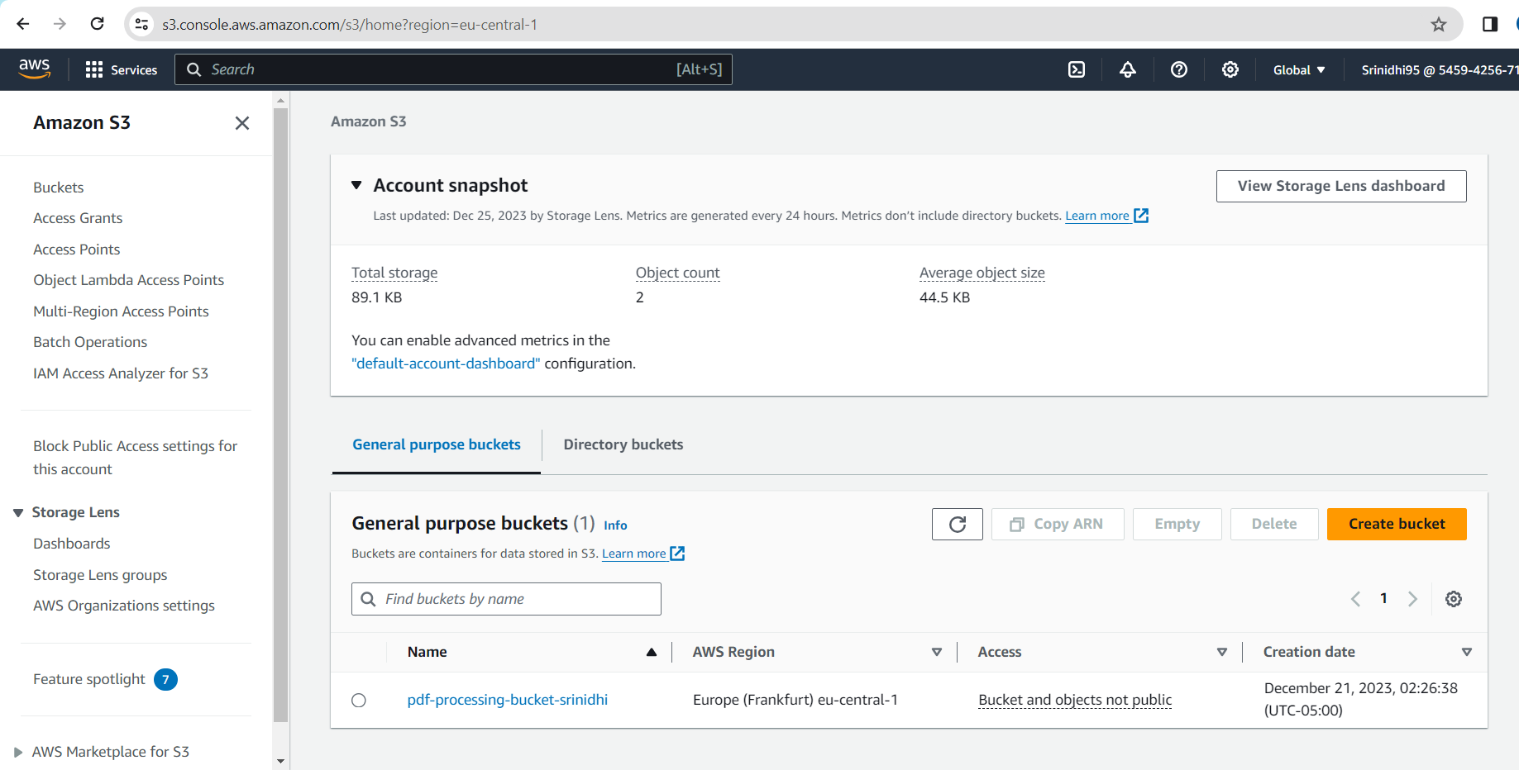

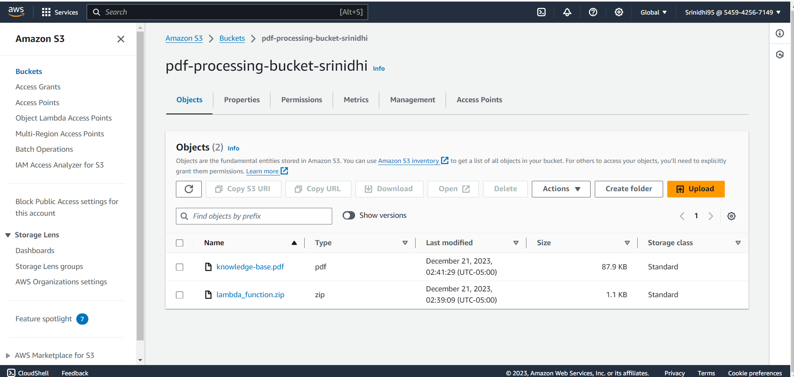

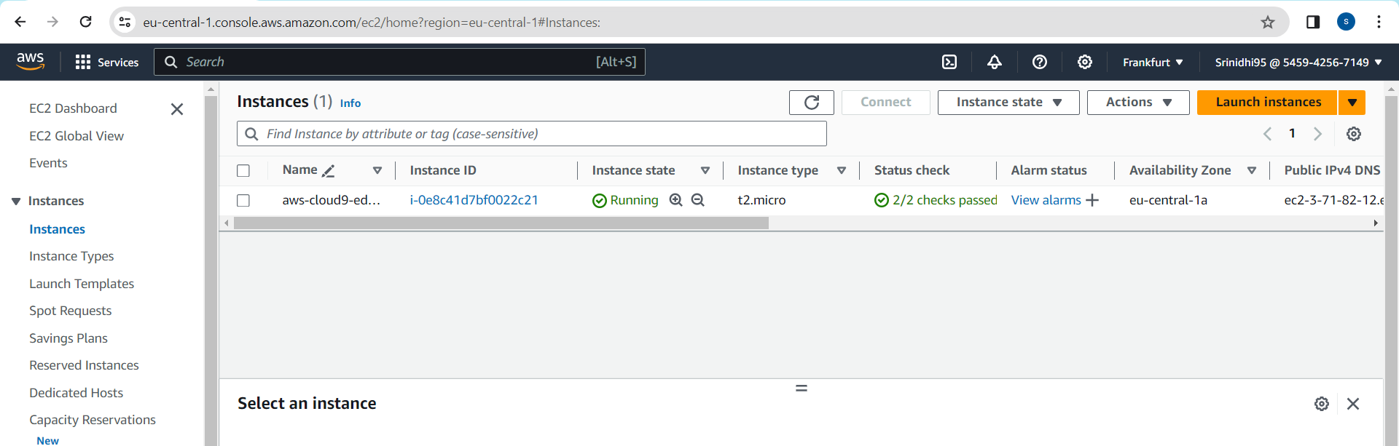

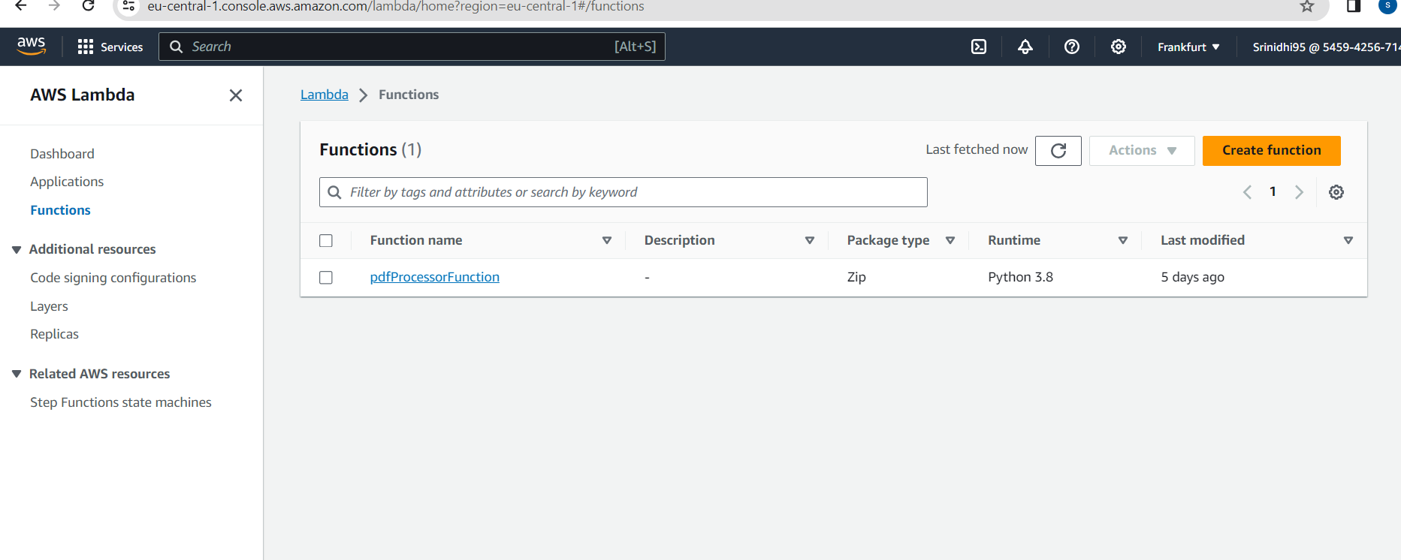

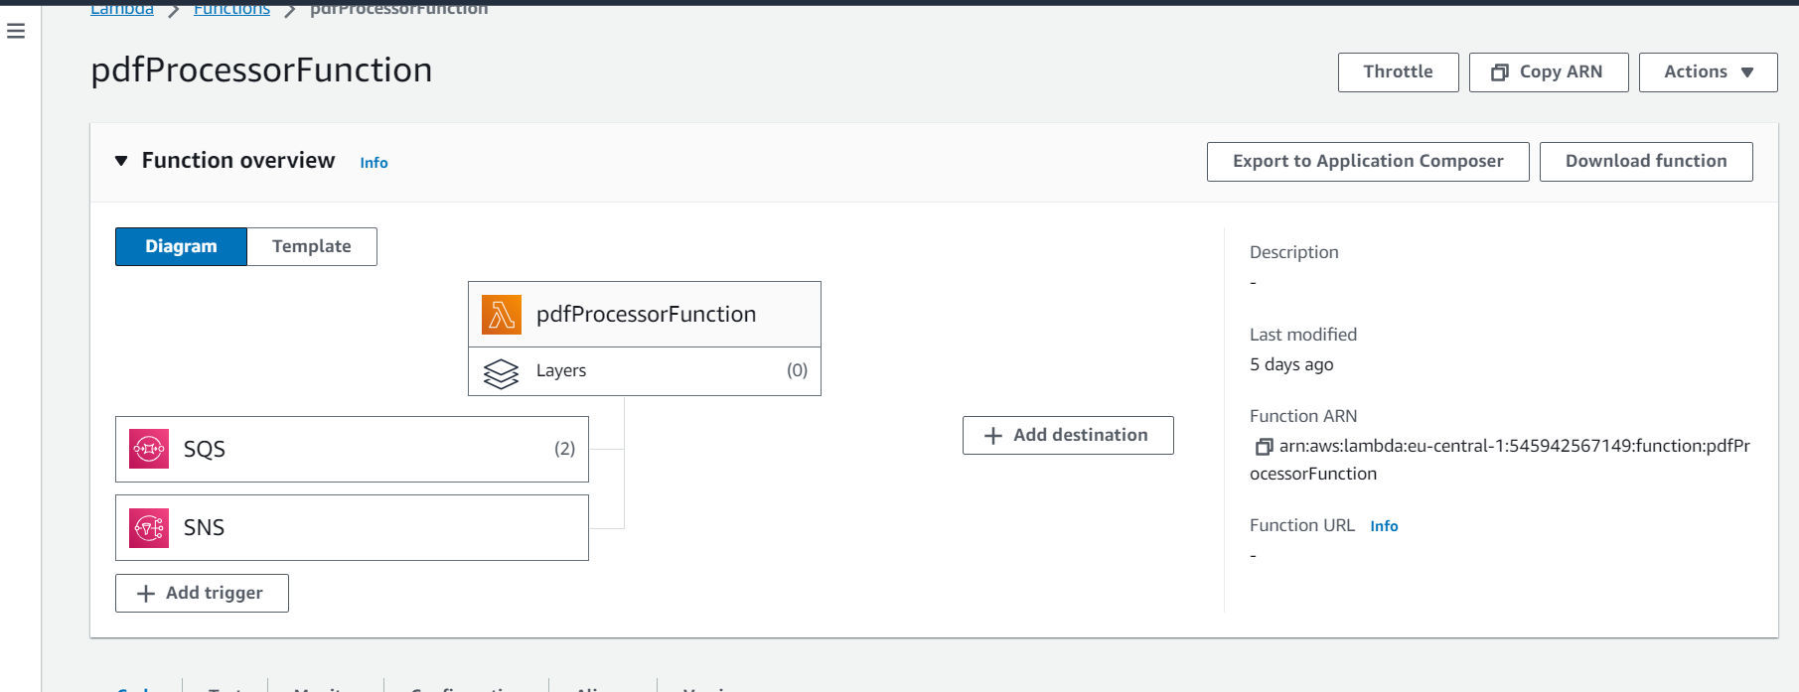

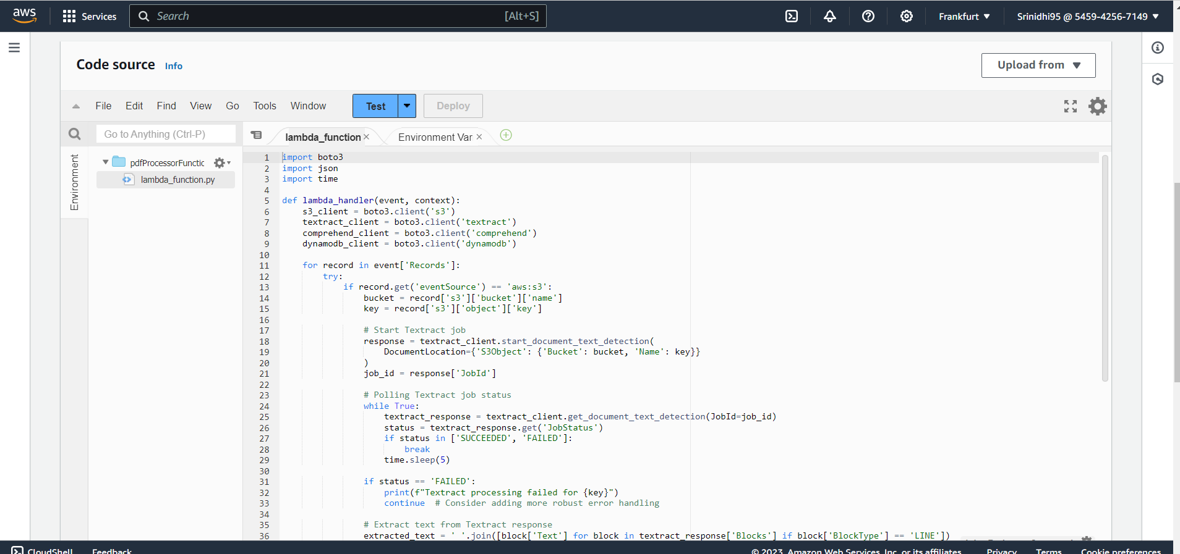

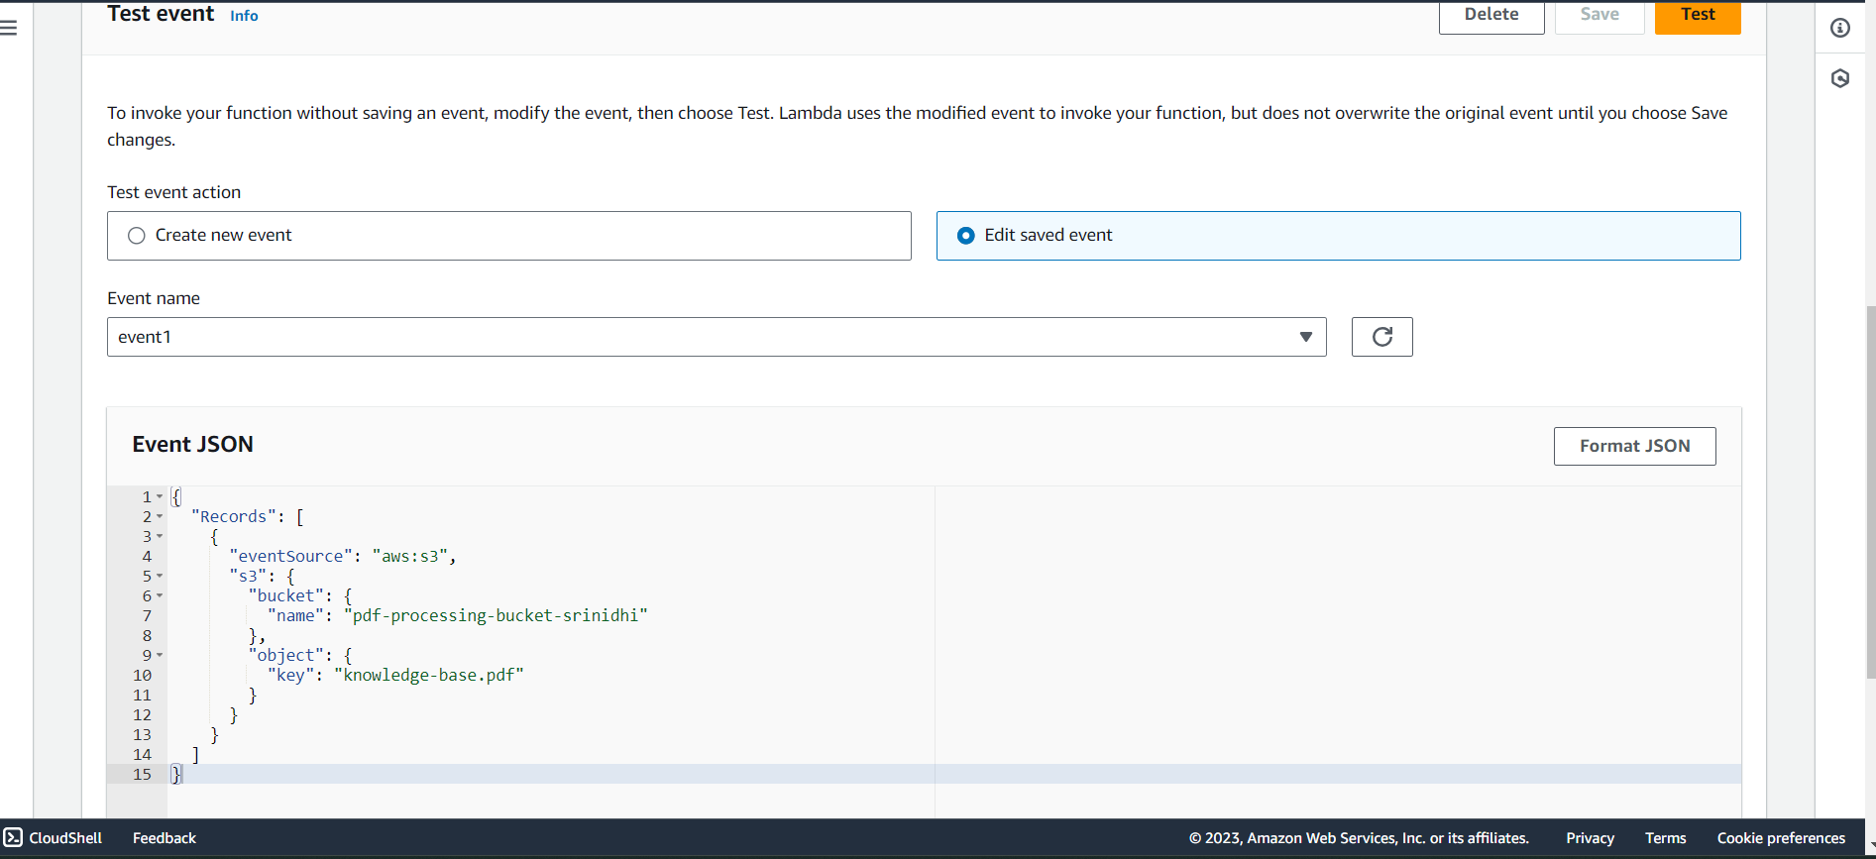

{

"Records": [

{

"eventSource": "aws:s3",

"s3": {

"bucket": {

"name": "pdf-processing-bucket-srinidhi"

},

"object": {

"key": "knowledge-base.pdf"

}

}

}

]

}

